Abhishek Garg

Ai-Voice Assistant JARVIS With Python

# (Annexure-I)

A Seminar Project Report

On

Voice Assistant JARVIS with Python

Submitted in partial fulfilment of the requirements for the

award of the degree of

**MCA**

**in**

**Session:20MCA2/B**

**By**

**(Abhishek,**

**UID : 20MCA1463)**

**Supervised By**

**Prof. Prabhsharan**

DESIGNATION



**University Institute of Computing**

**CHANDIGARH UNIVERSITY, GHARUAN, MOHALI, PUNJAB,140413**

# ACKNOWLEDGEMENT

In the present world of competition there is a race of existence in which those are having will to come forward succeed. Project is like a bridge between theoretical and practical working. With this willing I joined this particular project. First of all, I would like to thank the supreme power the Almighty God who is obviously the one has always guided me to work on the right path of life. Without his grace this project could not become a reality. Next to him are my parents, whom I am greatly in debated for me brought up with love and encouragement to this stage. I am feeling oblige in taking the opportunity to sincerely thanks to Er. Prabhsharan Kaur (Masters of Engineering (CSE), Btech(CSE)) and thanks to my worthy teacher of Computer Application, I am highly obliged in taking the opportunity to sincerely thanks to all the staff members of computer department for their generous attitude and friendly behavior. At last but not the least I am thankful to all my teachers and friends who have been always helping and encouraging me through out the year. I have no valuable words to express my thanks, but my heart is still full of the favors received from every person.

# DECLARATION BY THE CANDIDATE

I here by declare that the project report entitled "AI VOICE ASSISTANT JARVIS WITH PYTHON" submitted by me to Chandigarh University, Panjab. Abhishek in partial fulfillment of the requirement for the award of the degree of MCA in COMPUTER SCIENCE DEPARTMENT is a record of bonfide project work carried out by me under the guidance of Er. Prabhsharan Kaur (Masters of Engineering (CSE), Btech(CSE)). I further declare that the work reported in this project has not been submitted and will not be submitted, either in part or in full, for the award of any other degree or diploma in this institute or any other institute or university.

Abhishek Signature of the candidate

Date: 

# ***CERTIFICATE FROM THE SUPERVISOR***

This is to certify that the work incorporated in the project report entitled “AI VOICE ASSISTANT JARVIS WITH PYTHON ” is a record of work carried out by Abhishek, 20MCA1463. Under my guidance and supervision for the award of Degree of Master of computer Application in the faculty of Department of Computer Application of Chandigarh University, Gharuan, Mohali, Punjab,140413

To the best of my/our knowledge and belief the project report

1. Embodies the work of the candidates themselves,
2. Has duly been completed,
3. Fulfils the requirement of the Ordinance relating to the Master degree of the University and
4. Is up to the desired standard both in respect of contents and language for being referred to the examiners.

# Abstract

A voice assistant like as JARVIS, ALEXA etc., is a kind of voice-enabled non-natural intellect, be situated any extended only disposition in trickery pictures. At present, vocal sound is entrenched during a style of produce evocative of smart mobiles and smart speakers in user’s homes. (*Hey, Alexa: Stop Recording Me - The Washington Post*, n.d.)Additionally, voice assistants are getting important to our day-to-day lives. However, human behaviours form the technique we have a bent to move with the rest of the region. VA attitudes may have an impact on our daily observational learning. (*Waiting for a Sales Renaissance in the Fourth Industrial Revolution: Machine Learning and Artificial Intelligence in Sales Research and Practice - ScienceDirect*, n.d.)We analysed different VA (voice assistant) voices, three of which are frequently featured.

Microsoft's Cortana, Google's Assistant, and Apple's Siri are among the brands which are being deployed. Alexa is a virtual assistant developed by Amazon.

If we see the report of **Wireless Virtual Access Point** (VAP) on client expertise, then it applies pros. And cons. To extend flow theory uncover consequences and voice interaction flow experience. (Liu et al., 2021)Voice communication with a JARVIS that includes determined brilliance, seriousness, and innovative thinking enables customers to demand, as per our investigation. voice interaction with both the administration of their voice interactions with the with the virtual assistant, perform better in their voice interactions, and interact in chief behaviour and attitude. Consumer pleasure and a willingness to continue mistreating voice assistants are the results of consumers' experimental behaviour. Ai - powered systems are increasingly have been used in daily situations, which is frequently accelerated by the web's appearance and extensive usage. AI technologies are one during all the emergence of new technologies with complex features at a rapid rate. Voice is currently integrated into a product style evocative of mobile phones (mobile apps) and smart speakers in buyers' homes. JARVIS are also becoming more and more important in our daily lives. Although anthropoid traits profile “how we engage with the world?”, voice assistant personalities may have an effect on how we interact with our environments on a day-to-day source. Buyers' intrusive behaviour ends up in client satisfaction and consumers’ disposition to continue mistreatment voice assistant. the aim of this project to look at how Python produced voice assistants and how we may utilise them, as well as if they are an essential part of our lives in the up-to-date.(Munoz et al., 2021) Windows and microcontrollers reminiscent of Arduino and raspberry. If the devices will hear the user for the request or handle the daily affairs, then provide the proper response, it'll be abundant easier for users to speak with their devices and also the devices are going to be far “Smarter” as a personality's assistant. This project is focusing on the Raspberry voice assistant management development over the voice control (recognition, generate and analyse corresponding commands, intelligent responses automatically) that are required in daily life. Physically disable person may also use this Application. Voice SMS is an application developed during this work that enables a user to record and convert spoken messages into SMS text message. Speech recognition for Voice uses a way supported hidden Markov models (HMM - Hidden Markov Model). it's presently the foremost winning and most versatile approach to speech recognition. (van der Borgh et al., 2020)Therefore, we wish to speak concerning one straightforward reasonably assistant automaton that we have a tendency to build it, as a result of this type of automaton provide America a lot of facilitate in our daily needs. This paper talks concerning new technique to form robot that assist human in colloquial way. once arduous operating we conclude during this paper the procedure to make assistant robot mistreatment Raspberry-Pi 3 model B, speaker, electro-acoustic transducer and supplementary elements.

Voice assistant is one of these tools, and it may be implemented into a variety of intelligent systems. The fundamentals of voice assistant operation are discussed in this paper, as well as the major flaws and limits. The method of creating a local voice assistant without the need of cloud services is explained, allowing for a significant increase in the prospective significance of such gadgets.

“Choose something the user was going to do anyway – and make it easier for them.”

#### by Marcus Duffy – Head of design, Apadmi

**UNIVERSITY INSTITUTE OF COMPUTING**

**Master of Computer Applications**

**Minor Project Report**

**<AI Voice Assistant Jarvis with Python>**

# Preface

As a part of the MCA Circulam and in order to gain practical Knowledge in the field of computer Application, I created a project on “AI voice Assistant JARVIS with Python”.

The Basic Objective behind doing this project report is to get knowledge of python programming and the way we can create a project.

In this project report I have including various concepts, effects and implications regarding the JARVIS.

Table of Contents

(Annexure-I) 1

ACKNOWLEDGEMENT 2

DECLARATION BY THE CANDIDATE 3

CERTIFICATE FROM THE SUPERVISOR 4

Abstract 5

Preface 8

Table of Figure 11

Chapter 1 13

1. Introduction 13

2. Objectives of the Project 16

3. Scope of the Project 16

Chapter2: System Analysis 17

4. RELATED WORK 17

5. NEED OF THE SYSTEM 18

6. WORKING PROCESS 20

7. Data Flow Diagram for Voice Assistant 21

8. ER – Diagram for voice Assistant 22

Chapter 3 : System Design 23

9. Flow chart for My project execution 23

10. Functionalities 24

11. Test Cases 25

a) Text To speech function 25

25

b) Speak Function 25

c) Voice option and speak rate 26

d) Time function 26

e) Date function 27

f) Greet us 27

g) Wish me function 28

h) Take command function 29

i) Main function 31

j) Wikipedia search 32

k) Send email 33

35

l) Chrome search 35

m) Logout, shutdown and restart 35

n) Play song 35

o) Remember function 35

p) Screenshot function 35

q) CPU and battery update 35

r) Joke’s function 35

Chapter 4 : Coding 36

12. Complete project Coding 36

38

39

13. Errors Handling 40

40

Chapter 5: Testing 41

14. Import Library 41

15. Modules 42

16. Checking Headphone 44

Chapter 6: Documentation 45

17. GOOGLE ASSISTANT 45

18. *Security* and Privacy Concerns 46

Chapter 7: Conclusion And Future Scope 47

19. Conclusion 47

20. Limitations and future research 48

References 48

# Table of Figure

Figure 1 Voice Commands 20

Figure 2 DFD for voice Assistant process 21

Figure 3 ER – Diagram for voice Assistant 22

Figure 4 Flow chart for My project execution 23

Figure 5Text To speech function 25

Figure 6 Speak Function 25

Figure 7 voice option and speak rate 26

Figure 8 Time Function 26

Figure 9 Datefunction 27

Figure 10 greet us 1 27

Figure 11 greet us part 1 27

Figure 12 Greet us fuction 2 28

Figure 13 wish me function 28

Figure 14 wish me function part 1 29

Figure 15 take command part 2 29

Figure 16 take command 1 29

Figure 17 take command 4 30

Figure 18 take command 3 30

Figure 19 main function 1 31

Figure 20 main function 2 31

Figure 21 main function 3 32

Figure 22 wikipedia search part 1 32

Figure 23 wikipedia search 1 32

Figure 24 wikipedia search 2 33

Figure 25 email 1 33

Figure 26 email 3 34

Figure 27 email 2 34

Figure 28 email 4 35

Figure 29 complete coding 1 36

Figure 30 Complete coding 2 36

Figure 31 completing coding 3 37

Figure 32 complete code 4 37

Figure 33 Complete code 5 38

Figure 34 Complete code 6 38

Figure 35 complete code 8 39

Figure 36 Complete code 7 39

Figure 37 Error 40

Figure 38 libraries 41

Figure 39 libraries 2 42

Figure 40 in built module 43

Figure 41 in built module 2 43

Figure 42google assistant tools 45

Figure 43 Smart Assistant Graph 46

# Chapter 1

### Introduction

Have you ever raised a voice assistant—Alexa, for instance, concerning her age or gender?

Sometimes, she says she is 5 and a few alternative times she says she has “finished her fifth trip round the sun and currently she is functioning on another one.” after you ask Apple’s Siri constant question, s/he answers,

“Well, I’m no Spring Chicken.

Or, Winter Bee.

Or Summer Squid, or Autumnal eutherian ….”.

Voice assistants (VA) are variety of voice-enabled computer science (AI). AI refers to some level of intelligence displayed by digital interfaces, or the power of algorithms to mimic intelligent human behaviour. Although AI refers to “cognitive” functions that we have a tendency to keep company with the human mind, as well as downside resolution associated learning (Ulaga & Kohli, 2018)VA within the type of mobile application embody Apple’s Siri, Amazon’s Alexa, Google Assistant, Microsoft Cortana, and among sensible speaker offerings are Amazon’s Echo, Google’s Home, and Apple’s Home. In any form, VA are revolutionizing consumers’ consumption culture and changing into a bigger a part of consumers’ social lives. Such VA alter users to navigate, hear music, send text messages, management smart home devices, build a phone call, order food, order an Uber ride or pizza, so on. consistent with National Public Radio and discoverer Research, 21% of USA citizens (53-million individuals) own sensible speakers, growing quickly from the 14-million folks that owned their 1st smart speakers in 2018.Huffman, vice chairman of Google Assistant, proclaimed that Google Assistant mobile application has been downloaded to 500- million devices. (Human, 2018)Google Assistant works with alternative smart machines, as well as dishwashers, ovens, and light-weight bulbs across a thousand brands Developers are engaged on algorithms to provide VA, social characteristics and specific personalities. A recent study documented people reacting to a golem that was asking them to not shut it off showing that individuals respond socially to golems demonstrating human-like behaviour. it's exhausting to modify off a robot beggary you not to. Amazon’s AI developers are presently making applications to provide Alexa a selected temperament , and to possess her become additional “conversational,” recall more, and interact in longer conversations(Kumar et al., 2018).If you raise Alexa however she is, her answer is “feeling pretty studious since the vacations are here and he or she has been learning some fun facts about The next step in interpersonal interactions is voice manipulation.. Voice assistants provide services to consumers using technologies such as voice recognition, speech synthesis, and natural language processing (NLP).

For IoT devices that lack bit capabilities, a voice interface is essential. Apart from smartphones, voice assistants are increasingly included in smart speakers, which are devices that have an electro-acoustic transducer and a speaker for communicating with consumers. Because information must be sent back and forth to centralised data centres, voice assistants require a cloud-based architecture.

Finally, the written response is sent to the cloud, where it is converted into voice and broadcast back to the user. According to Canali’s (2018), the number of smart speakers in use might reach 225 million by 2020 and 320 million by 2022.(Sharma & Syam, 2018)

Voice assistants offer a wide range of capabilities, including:

* Answer questions posed by users.
* Use streaming music services to listen to music.
* Set timers or alerts as necessary.
* Play video games.
* Make phone calls or send text messages.
* Purchases for construction.
* Provide weather-related information.
* alternative sensible gadgets management (lights, locks, thermostats, vacuum cleaners, switches).

Voice assistants' skills are always evolving. Amazon and Google have made platforms available to developers in order to expand the capabilities of their virtual assistants. Amazon Skills and Google Activities, similar to smartphone applications, significantly extend assistants' repertory, allowing users to execute new actions with voice control.

The literature investigates the similarities and differences of voice assistant devices and services. (Syam & Sharma, 2018)Furthermore, education will take place in both official and casual settings, so it's obvious to look at the use of voice assistants and sensible speakers by youngsters, adults, and the elderly, both inside and outside the room. a few years ago, software package programs were developed and run on the computer. Nowadays, sensible phones and every one alternative smart device are wide utilized by all people. This shows that the market is increasing quick and there are additional capabilities for Smartphone thanks to this wide use. This project is originated from a well-liked application from Apple known as “Siri” and Google voice Action. Siri application was free on the date once the iPhone4S was published. Google Voice Action may be utilized in any android version higher than 4.4. during this work we've developed an application for causation SMS messages, gap integral Applications like gallery, settings, camera, electronic communication and so forth that uses Google' speech recognition engine. the most goal of application is to use user voice commands to access sensible phone rather than using it manually. because it integrates most of the movable services for daily use, it may be helpful for obtaining a additional convenient life and it'll be useful for those folks that have disabilities for manual operations. this is often additionally a part of the explanation why it's been chosen as the degree project. The user may use their voice command to access the services of smart devices in this application. The user may easily access any or all parts of the internet, as well as use the devices' many services. During this project, physically disabled people or those with little knowledge of smart gadgets and how to use them effectively using voice or speech commands will be included.(Penrose, 1989)

### Objectives of the Project

1. **Recognition of speech**
2. **Python Backend**
3. **API Calls**
4. **Extraction of Context**
5. **System Calls**
6. **Text-To-Speech**

### Scope of the Project

* For blind people it is very helpful.
* It done all work by giving the commands.
* It reduces our time to do something.
* Give daily reports of your computer usage, internet usage, app usage, amount of time sitting down and can even give recommendations based on this data. An example would be - ‘you have been sitting on your computer for over an hour, go outside and take a break!’.
* allows you to schedule tasks to be done at a specific time. JARVIS will even remind you of certain tasks that need completing as those deadlines approach, making sure you don’t be late for anything!
* We are also using an AR-augmented reality app (self made) to control the appliances and manipulate them. If we want to switch on the electrical appliance we just need to focus the camera and it will start it and using a virtual button we can switch it off .
* If we want to know the electricity unit consumed by our appliances along with the cost of units we just need to send a text message to the device (Arduino) through our phone. The Arduino would be connected to the network through a GSM module which would reply with another text message containing the electricity unit and the total cost consumed by the appliances. This will help the user to get update on the electricity bill and they can decide whether to use the appliances on a regular routine or reduce it usage to save electricity.
* That will assist you throughout the day.
* For the dumb.

# Chapter2: System Analysis

### RELATED WORK

Every corporation of the teaching effectively utilizes his as well as her own set of research methodologies and approaches, each with its own set of advantages and disadvantages and influence on the finished product. One helper will do the synthesis. One can speak in a high-quality manner, while the other can do out chores more clearly and without the need for further explanations and corrections. Others are only capable of a limited number of tasks, but more precisely and in accordance with the user's wishes. Obviously, there is no such thing as a universal helper who can do everything equally well. The set of characteristics that an assistant possesses is entirely reliant on the developer's priorities. Because all systems support machine learning methods and utilise enormous amounts of knowledge acquired from a variety of sources and then trained on them, the source of this data, (Lenat & Guha, 1989)whether it's search engines, other sources of information, or social media, is important. The nature of the helper is determined by the amount of knowledge obtained from various sources.(Moravec, 1988)

Table 1 Technologies for constructing intelligent systems of interaction with a human by natural language.

|  |  |
| --- | --- |
| VOICE TECHNOLOGY | BRAIN TECHNOLOGY |
| Voice Activation | Voice Biometrics |
| Automatic Speech Recognition (ASR) | Dialog Management |
| (Teach-To-Speech (TTS) | Natural Language Understanding (NLU) |
|  | Named Entity Recognition NER) |

### NEED OF THE SYSTEM

Back within the 1980‟s associated 1990‟s, home computers didn’t trust dedicated monitors to show the operational systems, applications, and games. rather than paying further for a monitor, most console homeowners were happy to use their televisions only. however as so much as computers go, the laptop model of dedicated monitor was eventually wide adopted. the matter for an upper-middle-class human to shop for the pc system ought to be taken into consideration. (Searle, 1998) So, the requirement of a cheap, different system raised; wherever the expensive ADPS should have an alternative. additionally for security purpose of home, tiny offices, there was a requirement of the system which may offer options corresponding to automatic face recognition and voice recognition that ought to be out there in all-time low rate and little in size. the speed and also the size downside were coated wherever made-up Raspberry Pi model by embedded makers giving extraordinarily super quality of minicomputer. Here arises the necessity of the system. The Raspberry pi could be a series of single board pc developed in Wales by raspberry pi foundation. All raspberry pi includes constant video-core IV GPU and either one core ARMv6 or newer ARMv7 quad-core.it is of 256 or 512 mb RAM. It essentially uses UNIX operational system kernel base operating systems.(Penrose, 1989) The install manager of Raspberry pi is NOOBS. For storage it uses SDHC and small SDHC Back within the 1980‟s and 1990‟s, home computers didn’t trust dedicated monitors to show the operating systems, applications, and games. rather than paying further for a monitor, most console homeowners were happy to use their televisions only. however as so much as computers go, the laptop model of dedicated monitor was eventually wide adopted. the matter for an upper-middle-class human to shop for the pc system ought to be taken into consideration. So, the necessity of a cheap, different system raised; where the expensive ADPS ought to have an alternative. additionally for security purpose of home, small offices, there was a demand of the system which may offer options corresponding to automatic face recognition and voice recognition that should be out there in all-time low rate and little in size.(Minsky, 2006) the speed and also the size downside were coated wherever made-up Raspberry Pi model by embedded makers giving extraordinarily super quality of minicomputer. Here arises the necessity of the system. The Raspberry pi could be a series of single board pc developed in Wales by raspberry pi foundation. All raspberry pi includes constant video-core IV GPU and either one core ARMv6 or newer ARMv7 quad-core.it is of 256 or 512 mb RAM. It essentially uses kernel base operating systems. The install manager of Raspberry pi is NOOBS. For storage it uses SDHC and small SDHC(Shende et al., 2019)

### WORKING PROCESS

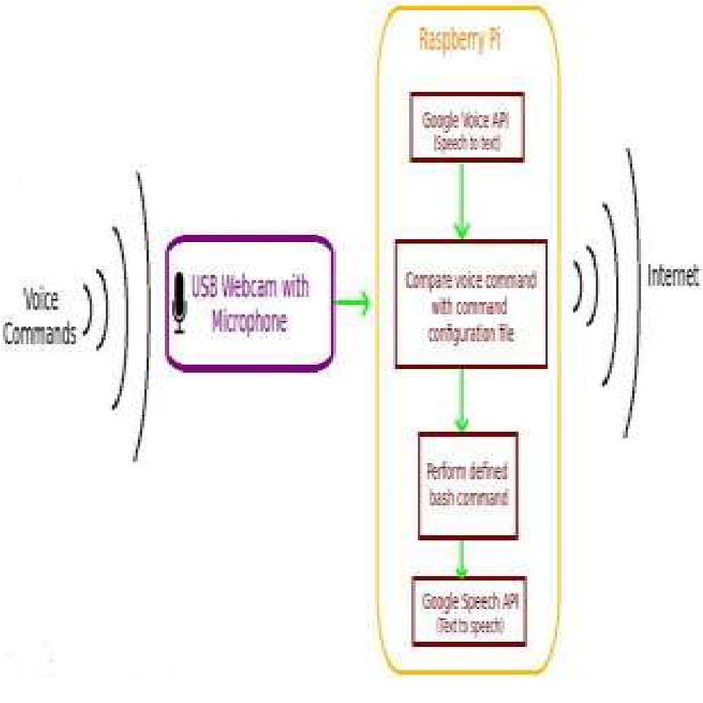This code relies on exploitation the Google voice and speech API’s. The voice is recorded using the Microphone. Then using Google speech API’s, it's born-again to text. (O’Brien & Marakas, 2011)The text is compared with antecedental designed commands in configuration command file. The text matches with any of the commands, therefore it performs the precise task. when finding the specified commands, the bash command for task is executed. The speed of this method is admittedly in no time and rely on the speed of the net connected.(Weizenbaum, n.d.)

Figure 1 Voice Commands

### D**ata Flow Diagram for Voice Assistant**

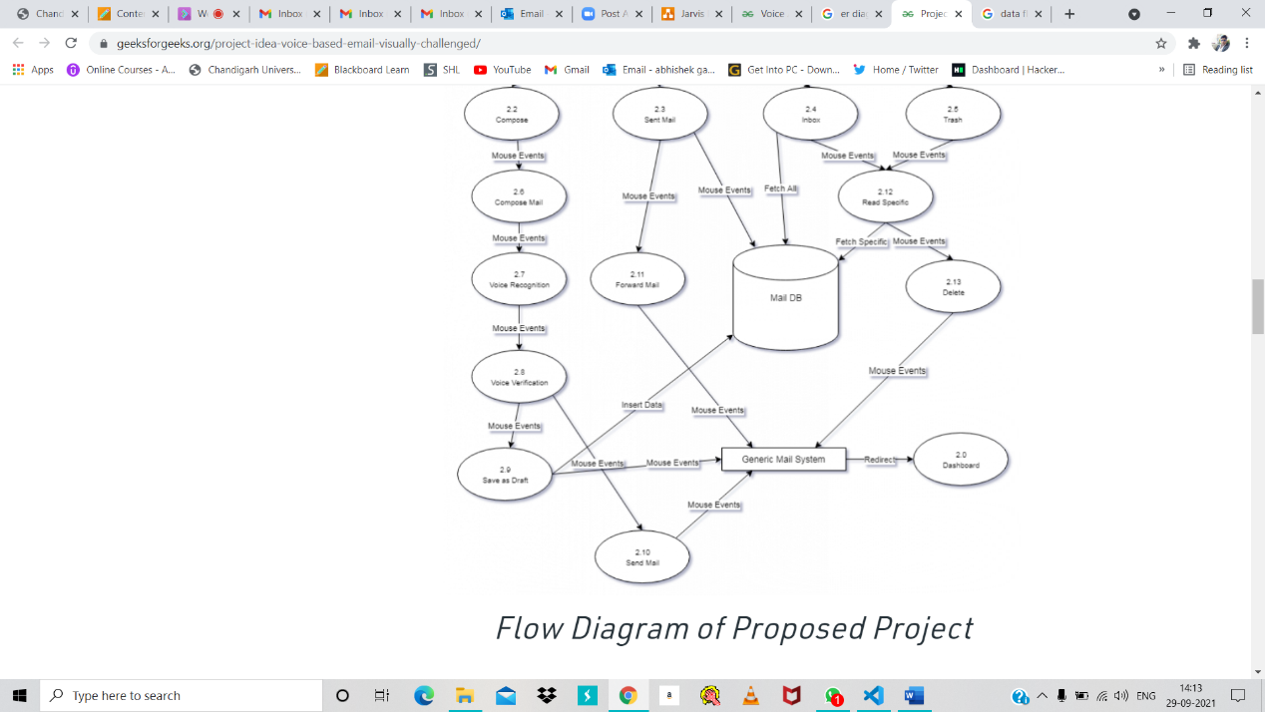

Figure 2 DFD for voice Assistant process

This is a data flow diagram of JARVIS. By this we can understand the flow of data or information between user to system. It is a framework or pattern of the data systems. It include data input form, where it store the data, which type of output given by him. So it show all process or path of data that completes the process.

### ER – Diagram for voice Assistant

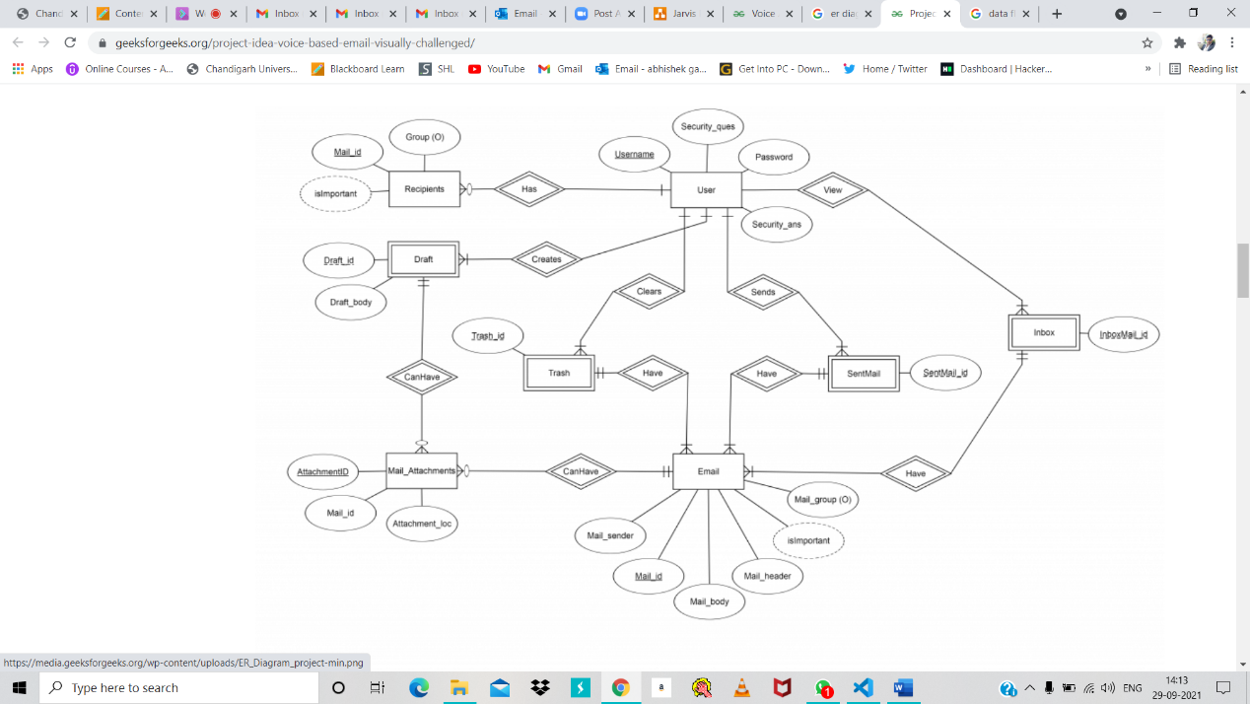

Figure 3 ER – Diagram for voice Assistant

This is a ERD (Entity-Relationship Diagram) for voice assistant JARVIS. By this diagram, we represent or show the relationship between the entities or data objects that are stored in a database of JARVIS. It shows the database design of JARVIS software.

By help of this we can understand the concept of JARVIS functionality.

# Chapter 3 : System Design

### Flow chart for My project execution

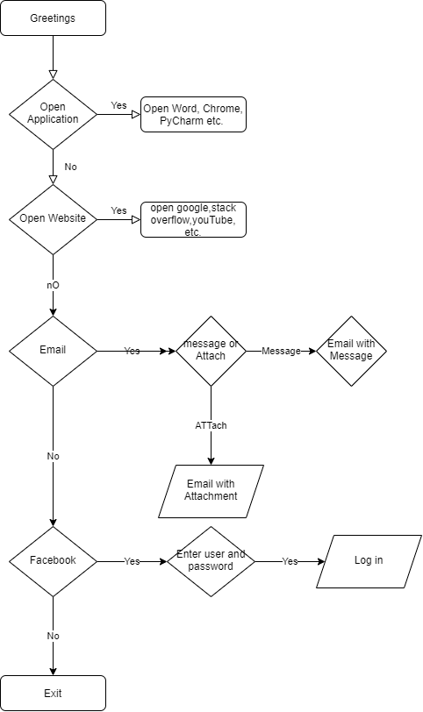

Figure 4 Flow chart for My project execution

This is a flowchart of Jarvis. From starting to end it show all content process.

### Functionalities

* It converts text-to-speech.
* We can change the voice of Jarvis.
* We can control the speak rate as well as voice option.
* We can also set date and time function.
* We can also use wish me function.
* We can also give commands to JARVIS.
* We can also call for Wikipedia search for any topic.
* We can also send email to anyone.
* We can also open some website like google, YouTube etc.
* We can also perform logout, restart, shutdown function in our system.
* We can also play song by giving command.
* We can also record something by use of remember function.
* We can also take screenshot.
* We can also ask to CPU and battery update.
* We can also ask for jokes to him.

### Test Cases

## Text To speech function

### 

Figure 5Text To speech function

Text to speech function is used to convert text into speech form. Like in the above figure, hello world convert into speech form by JARVIS.

## Speak Function

Figure 6 Speak Function

## Voice option and speak rate

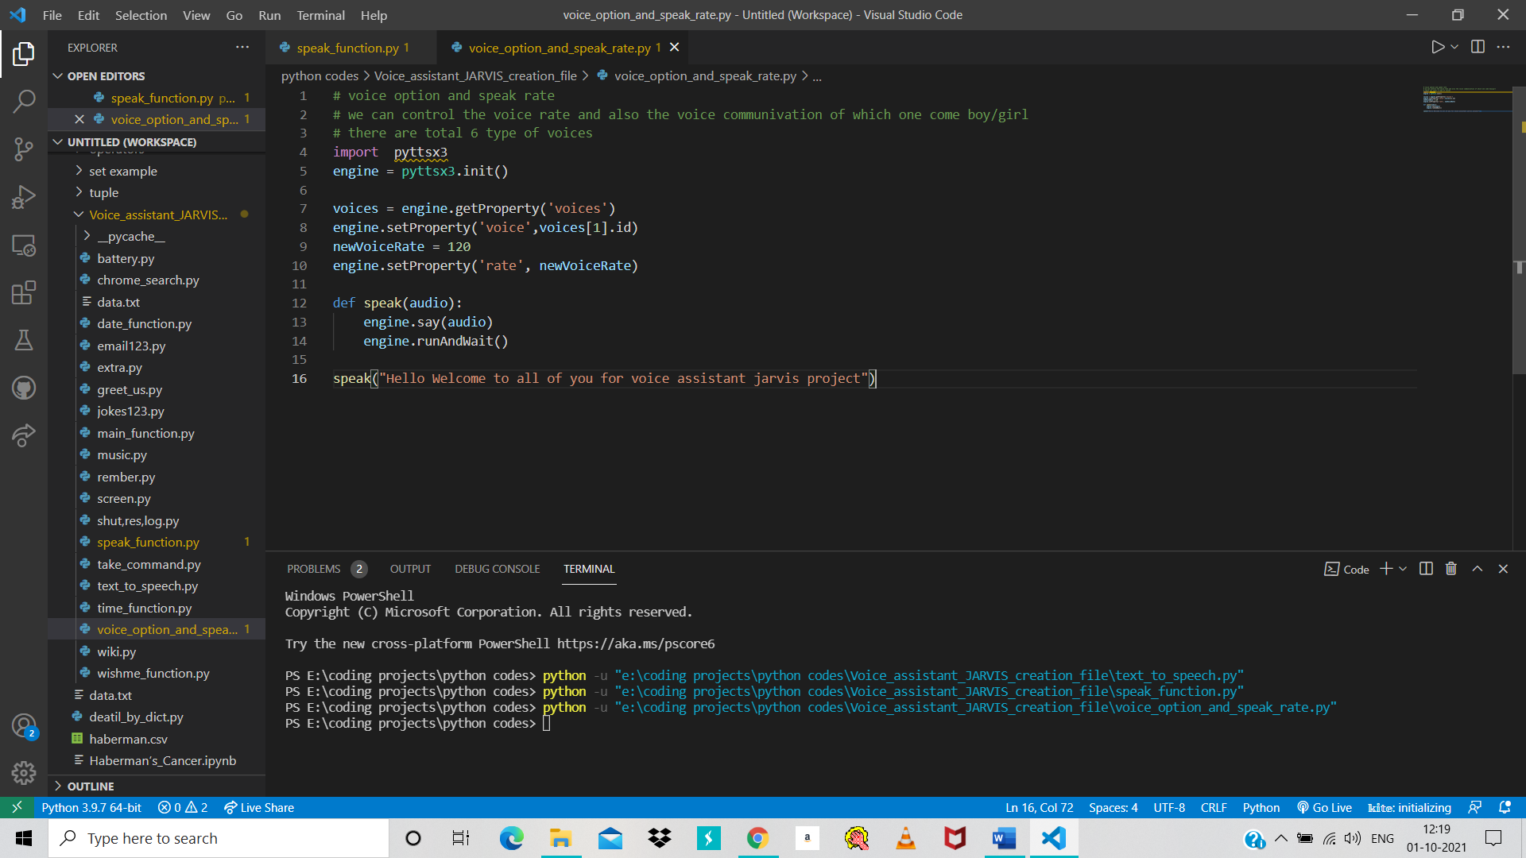

Figure 7 voice option and speak rate

## Time function

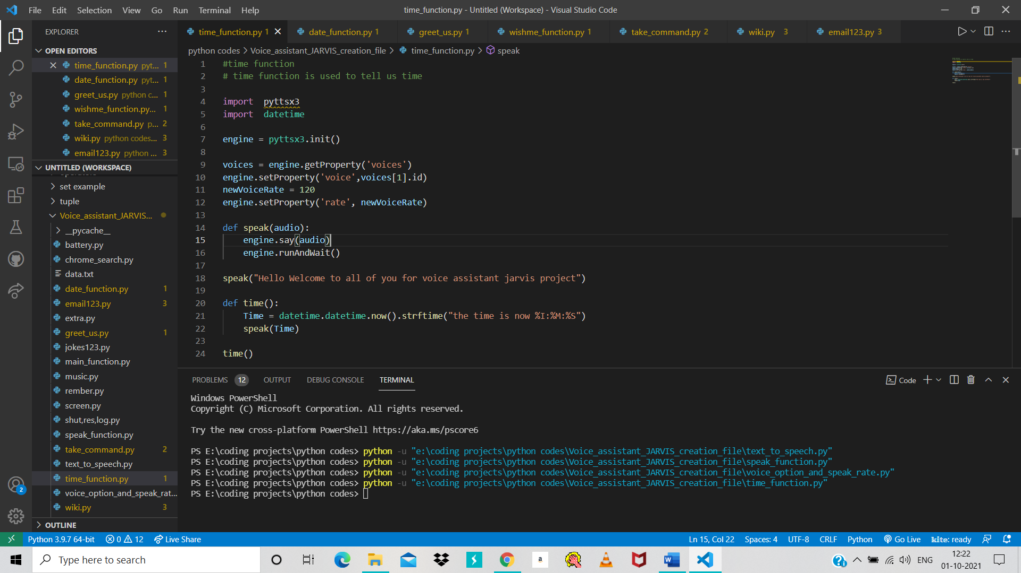

Figure 8 Time Function

## Date function

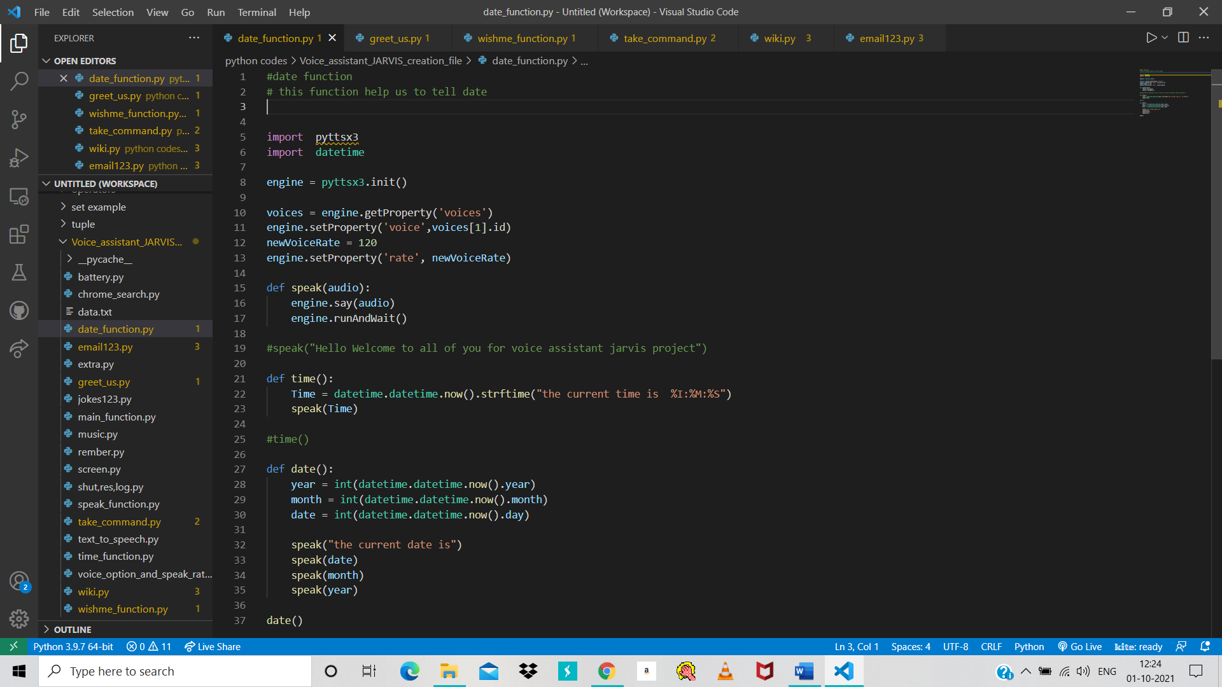

Figure 9 Datefunction

## Greet us

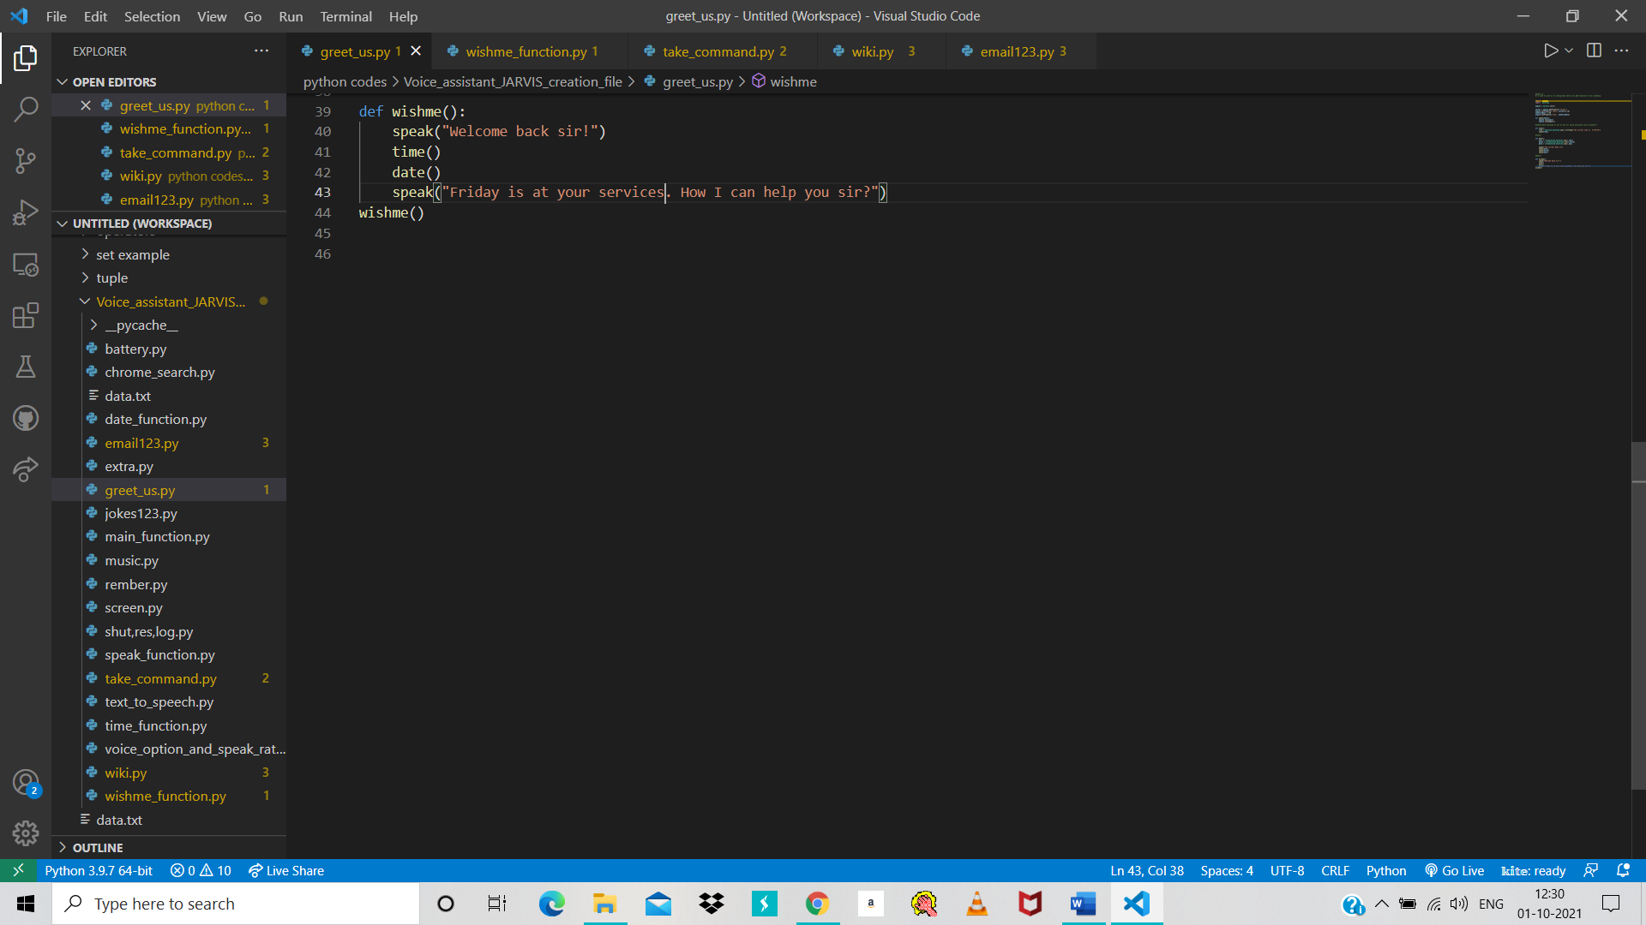

Figure 10 greet us 1

Figure 11 greet us part 1

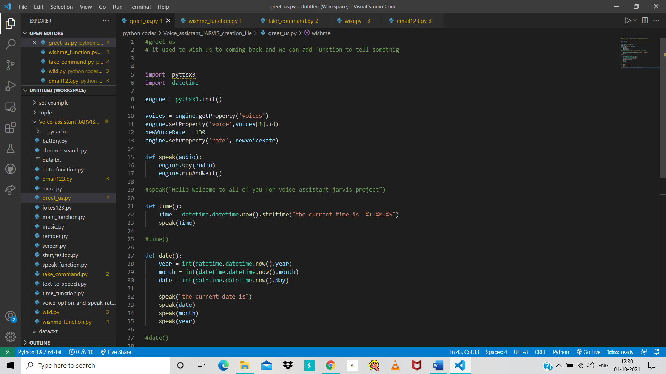

Figure 12 Greet us fuction 2

## Wish me function

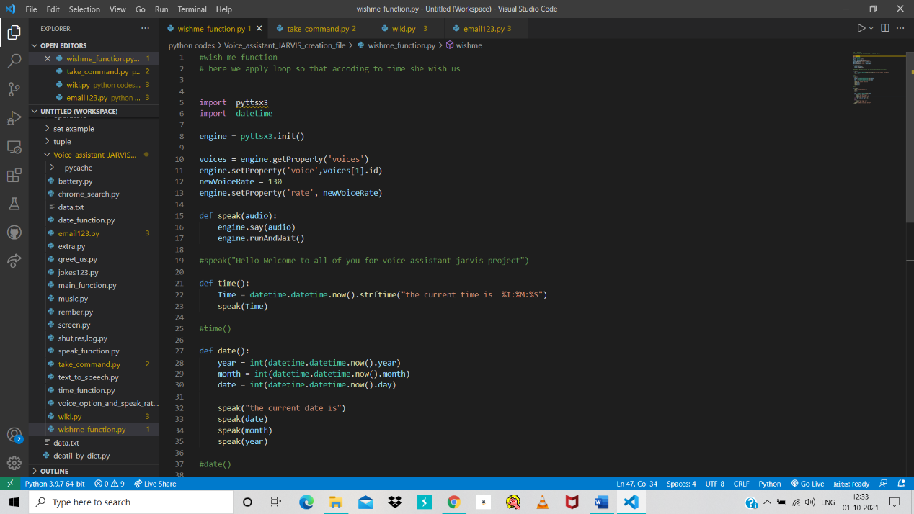

Figure 13 wish me function

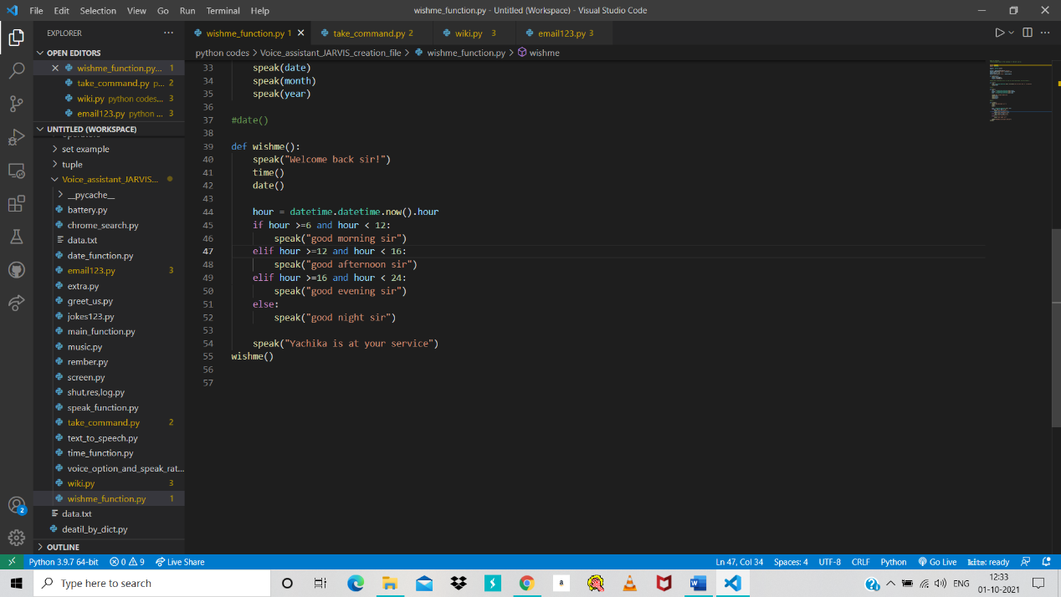

Figure 14 wish me function part 1

## Take command function

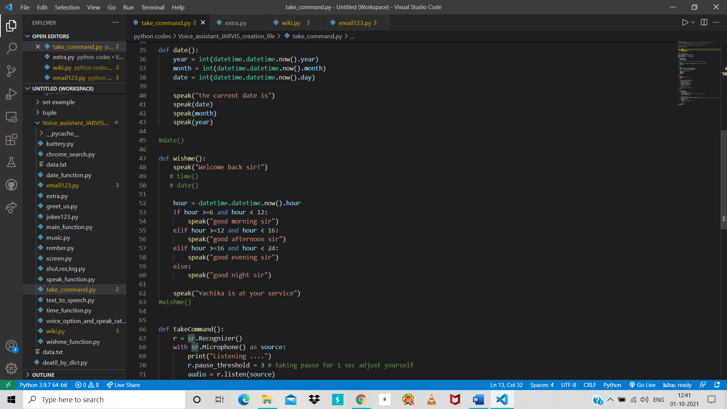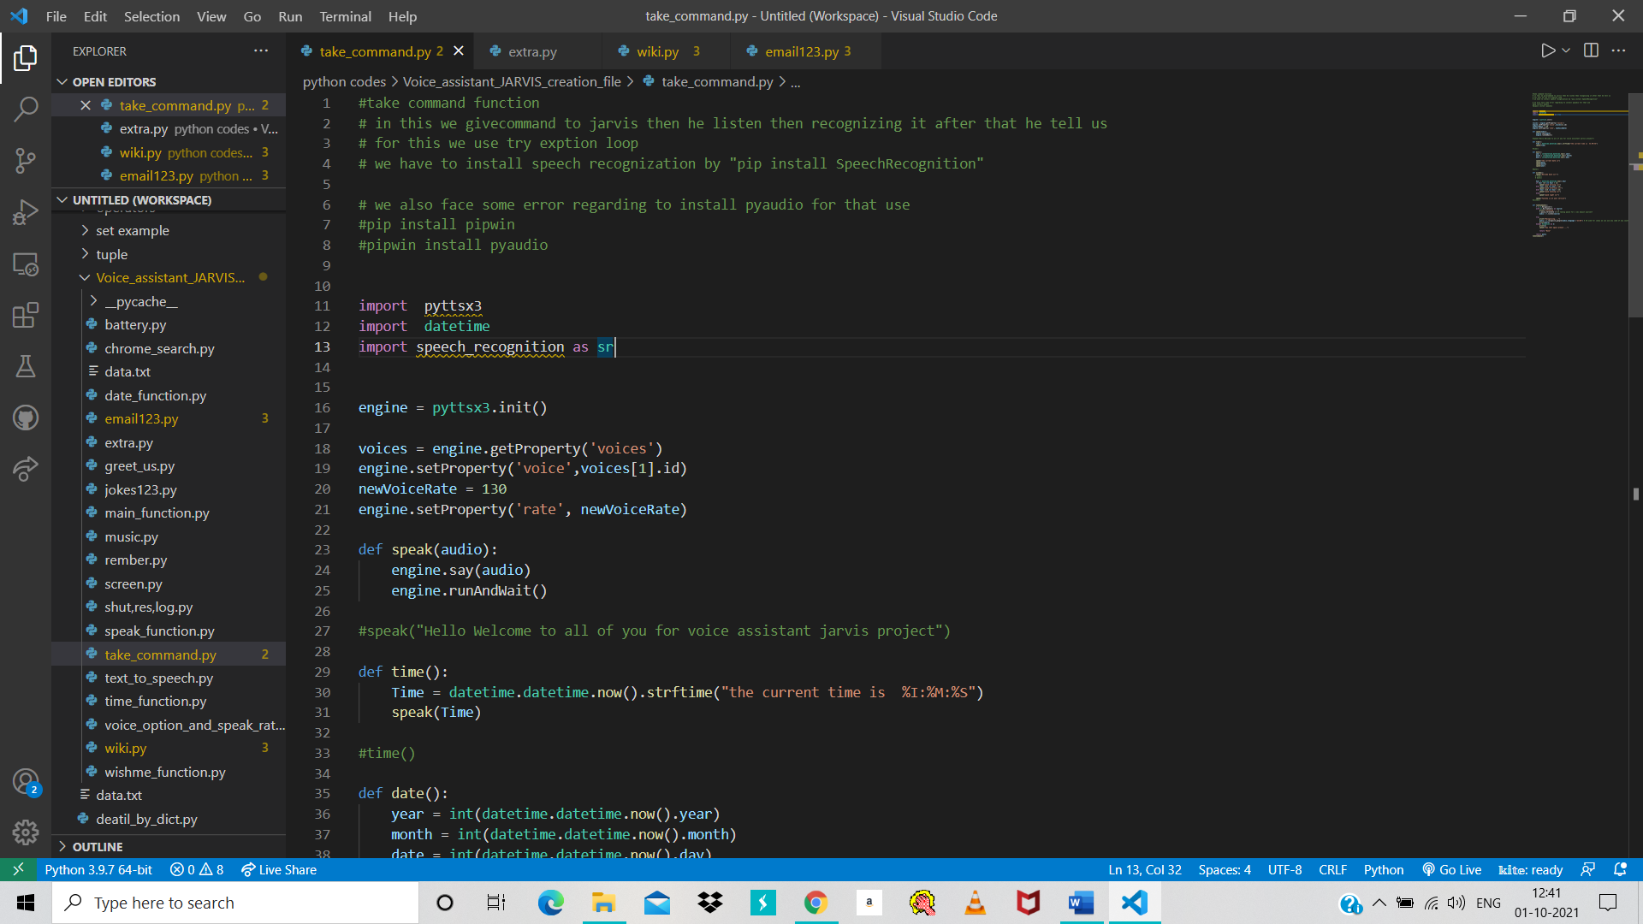

Figure 15 take command part 2

Figure 16 take command 1

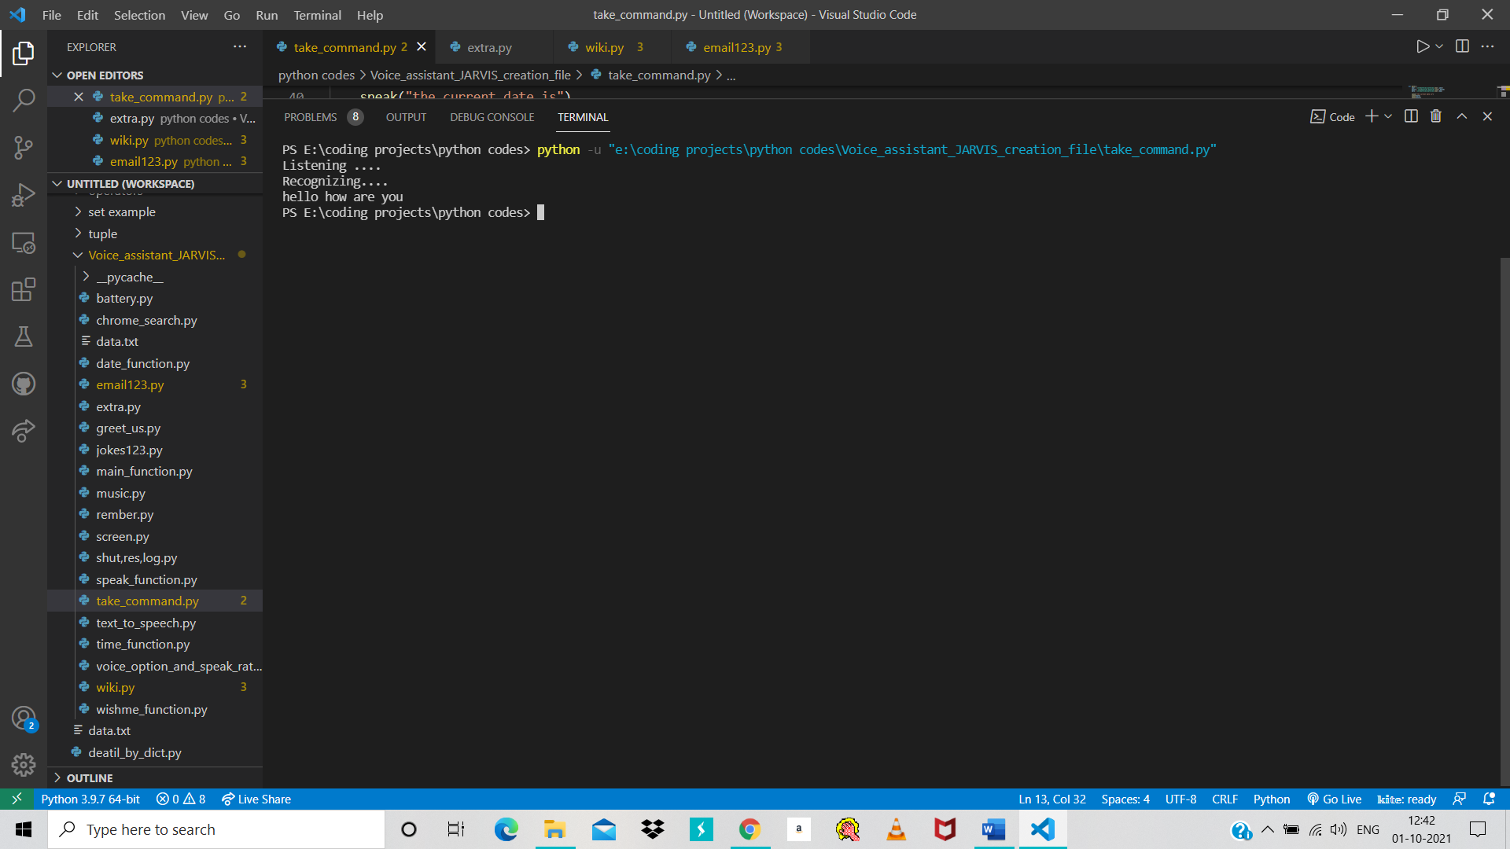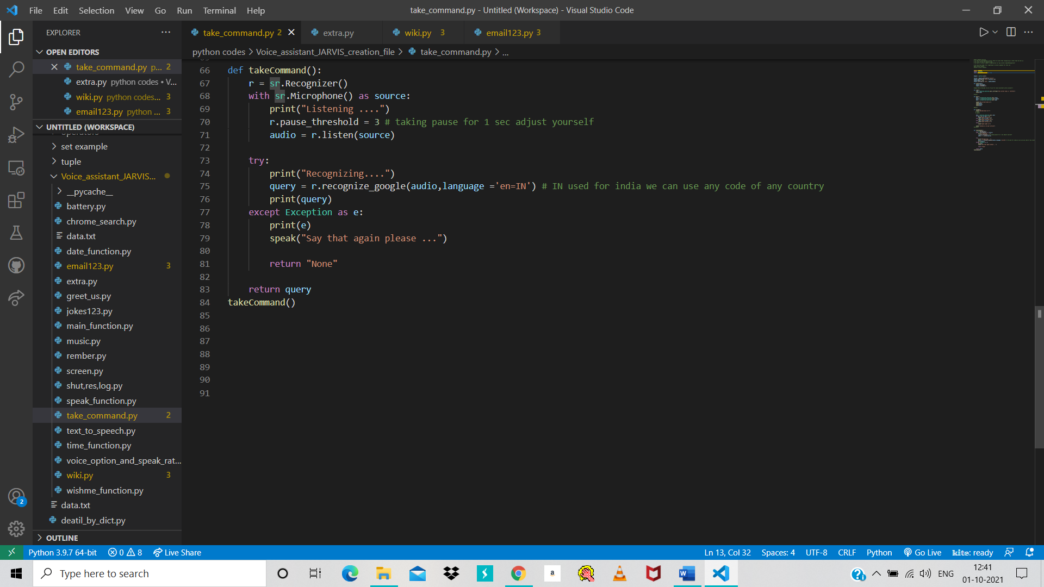

Figure 17 take command 4

Figure 18 take command 3

## Main function

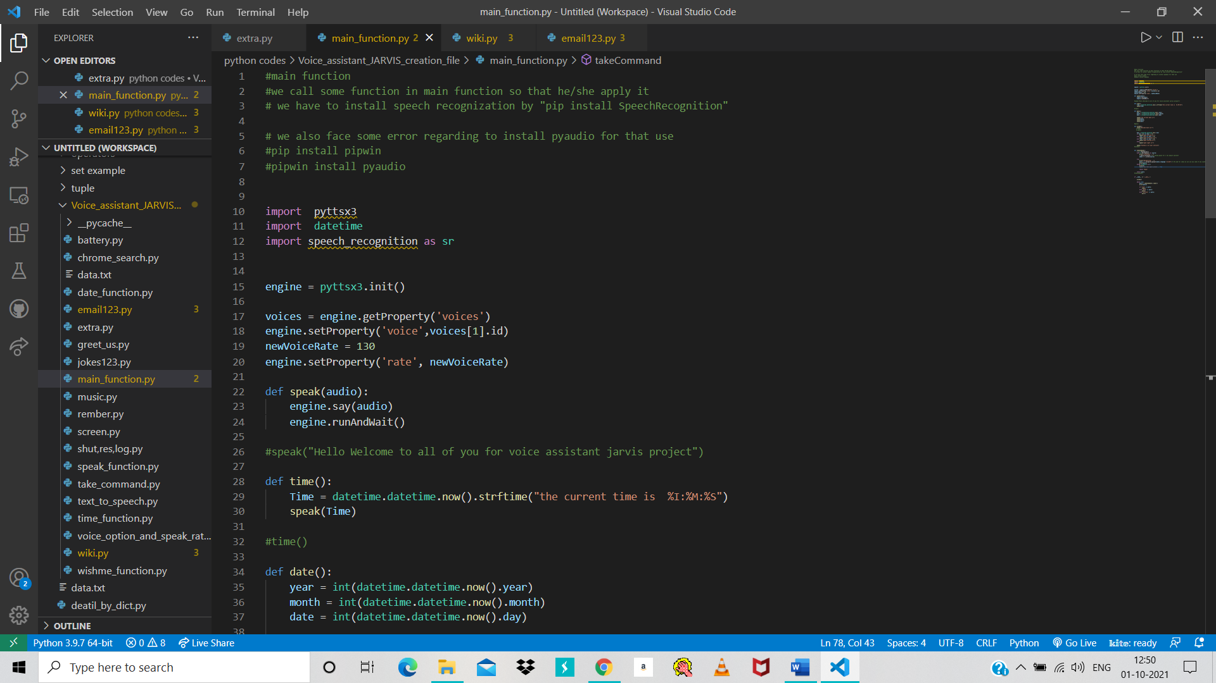

Figure 19 main function 1

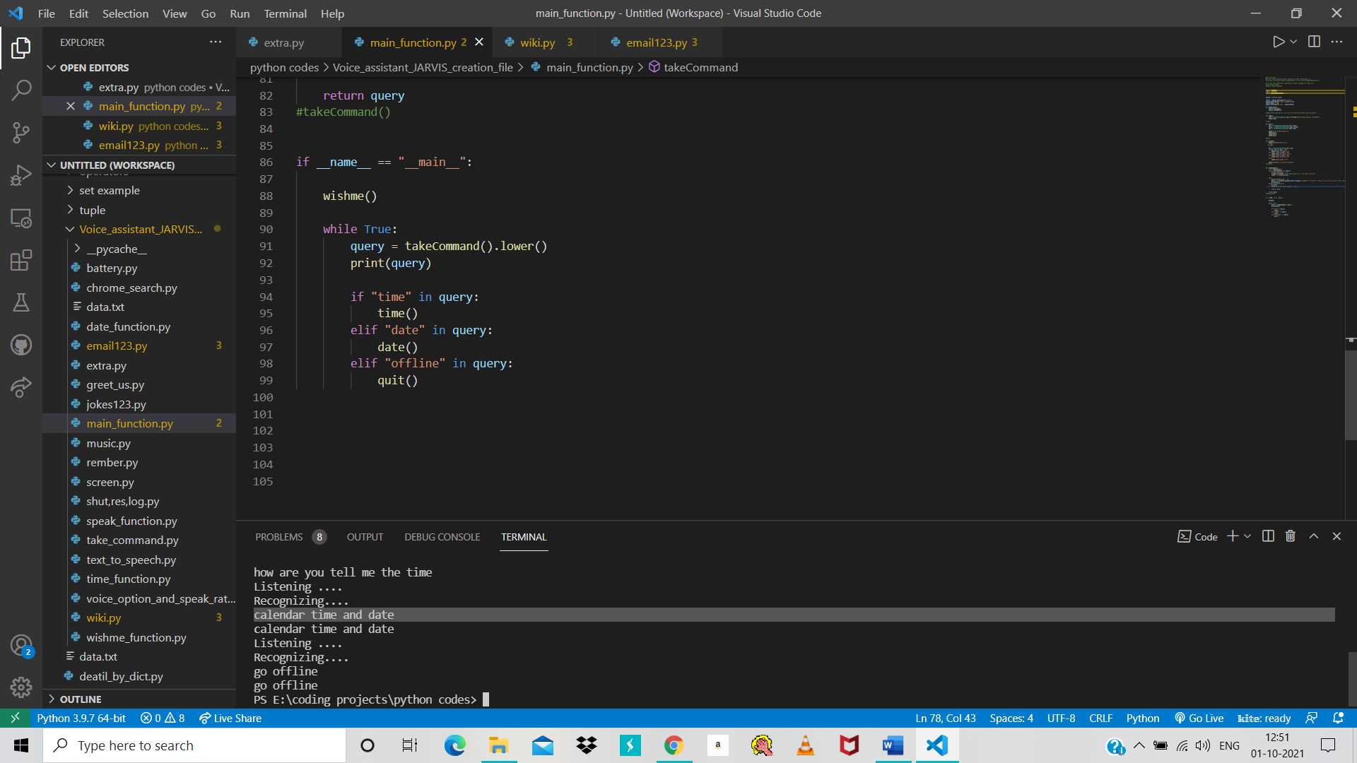

Figure 20 main function 2

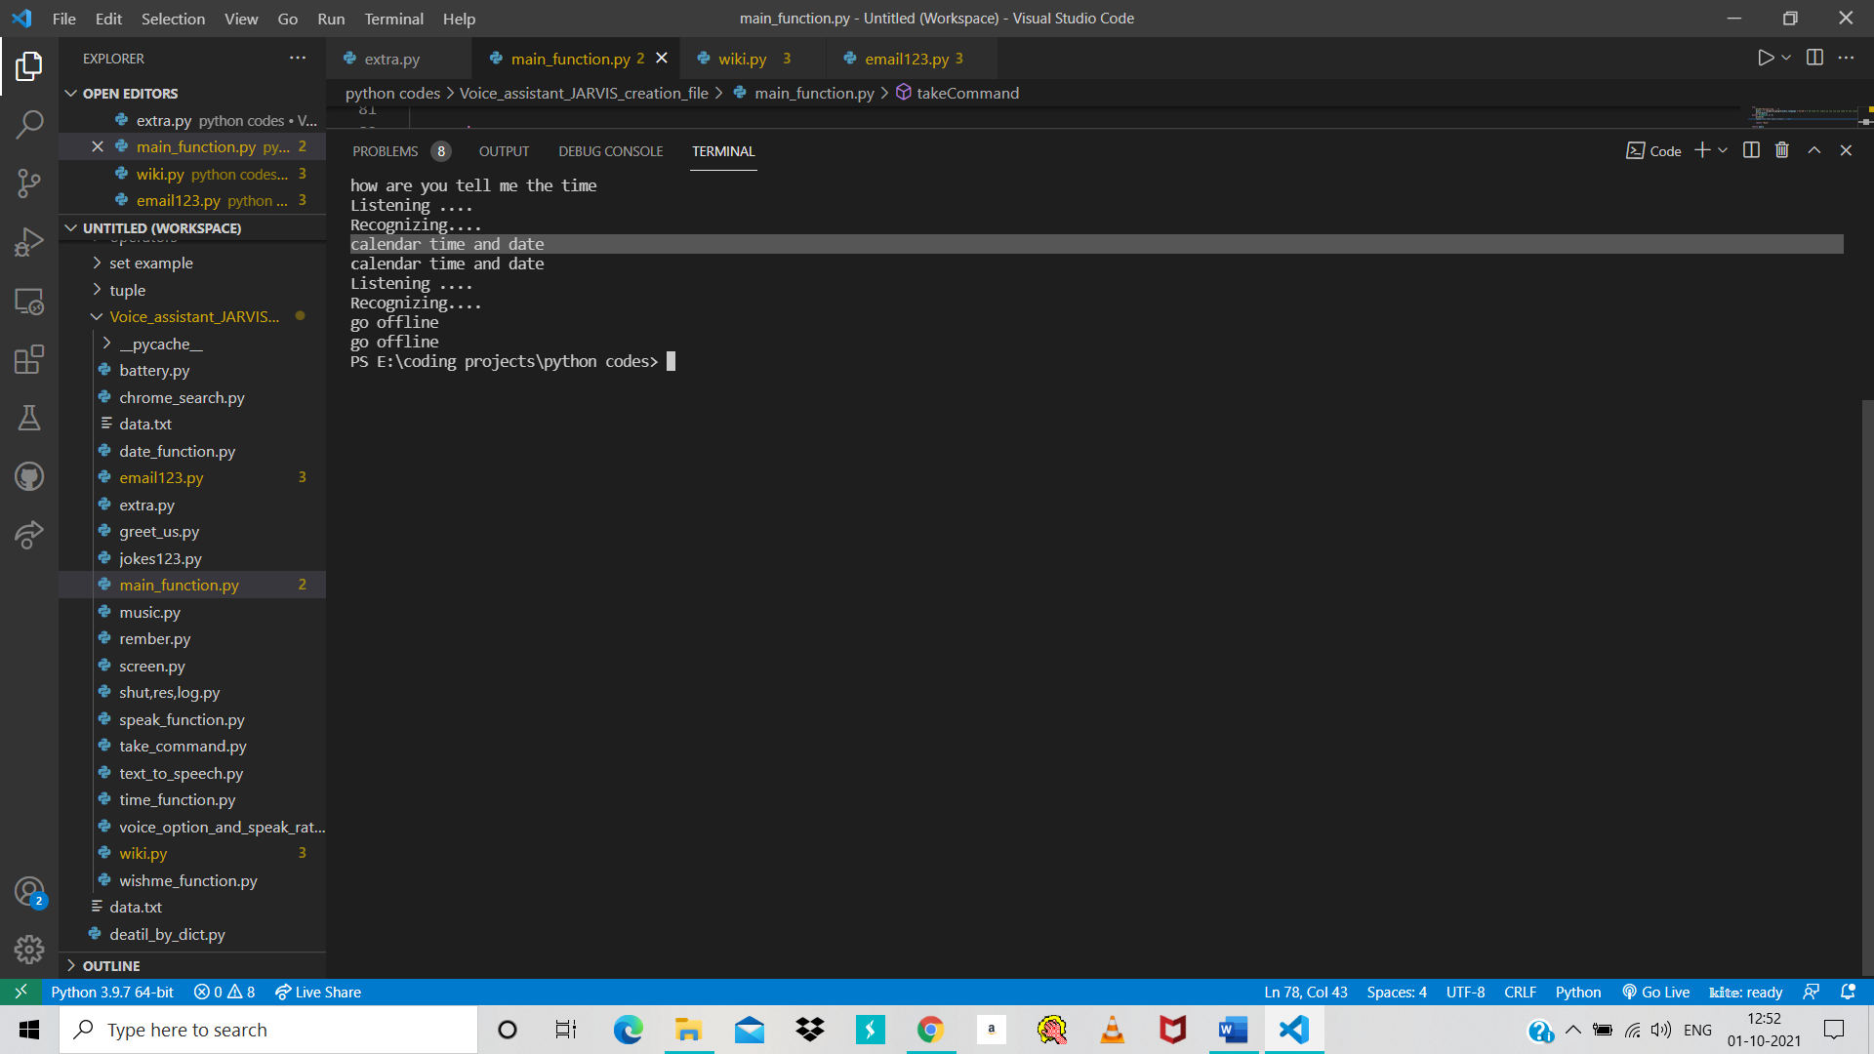

Figure 21 main function 3

## Wikipedia search

Figure 22 wikipedia search part 1

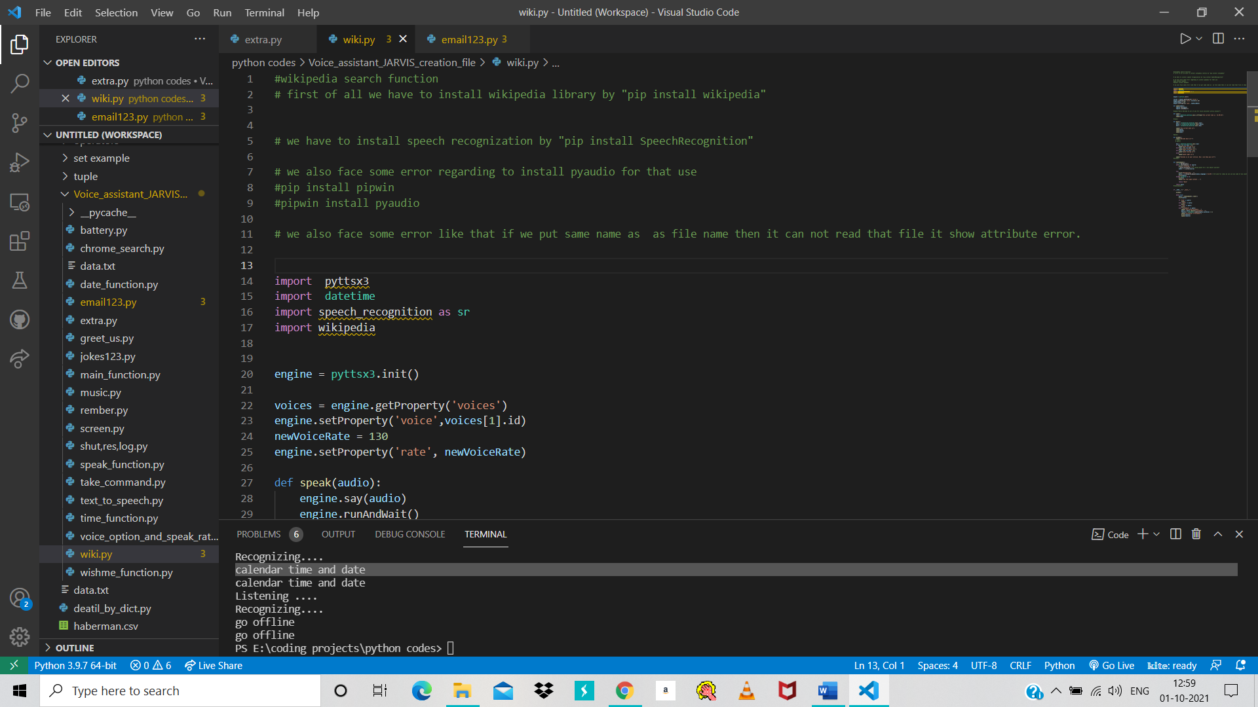

Figure 23 wikipedia search 1

#### 

Figure 24 wikipedia search 2

## Send email

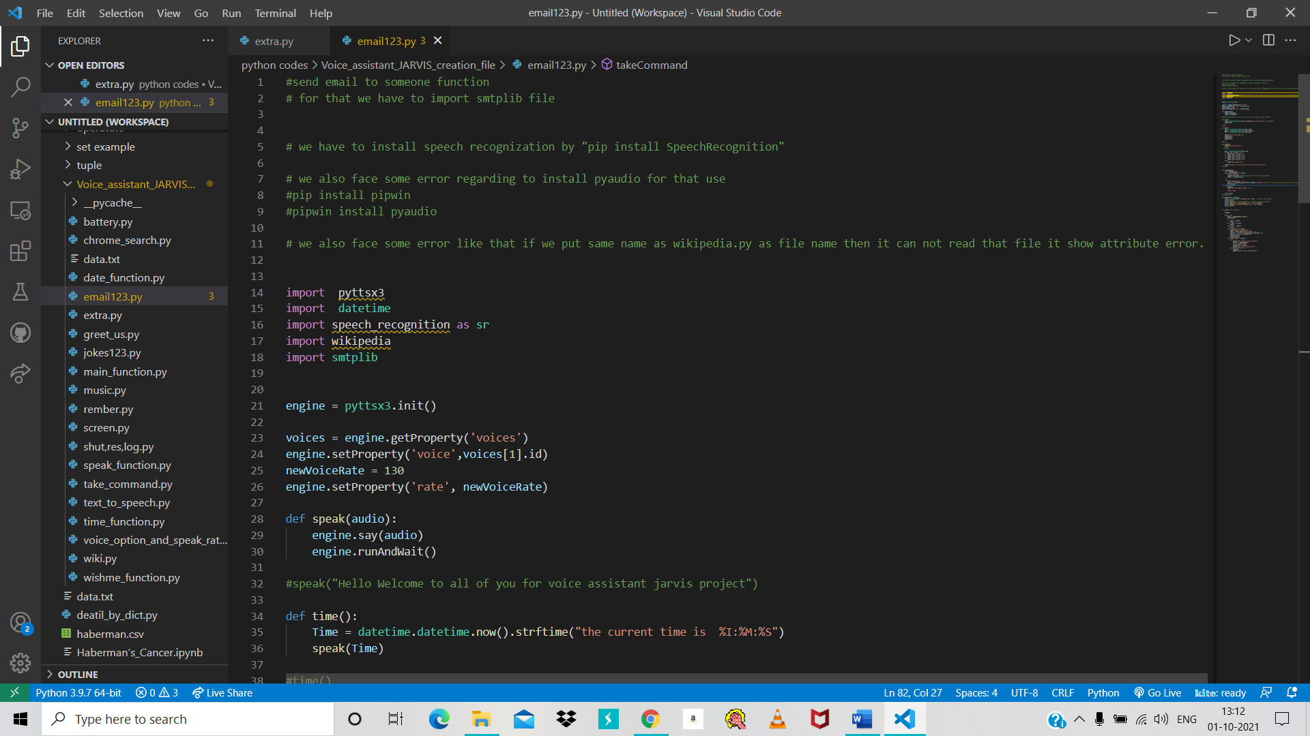

Figure 25 email 1

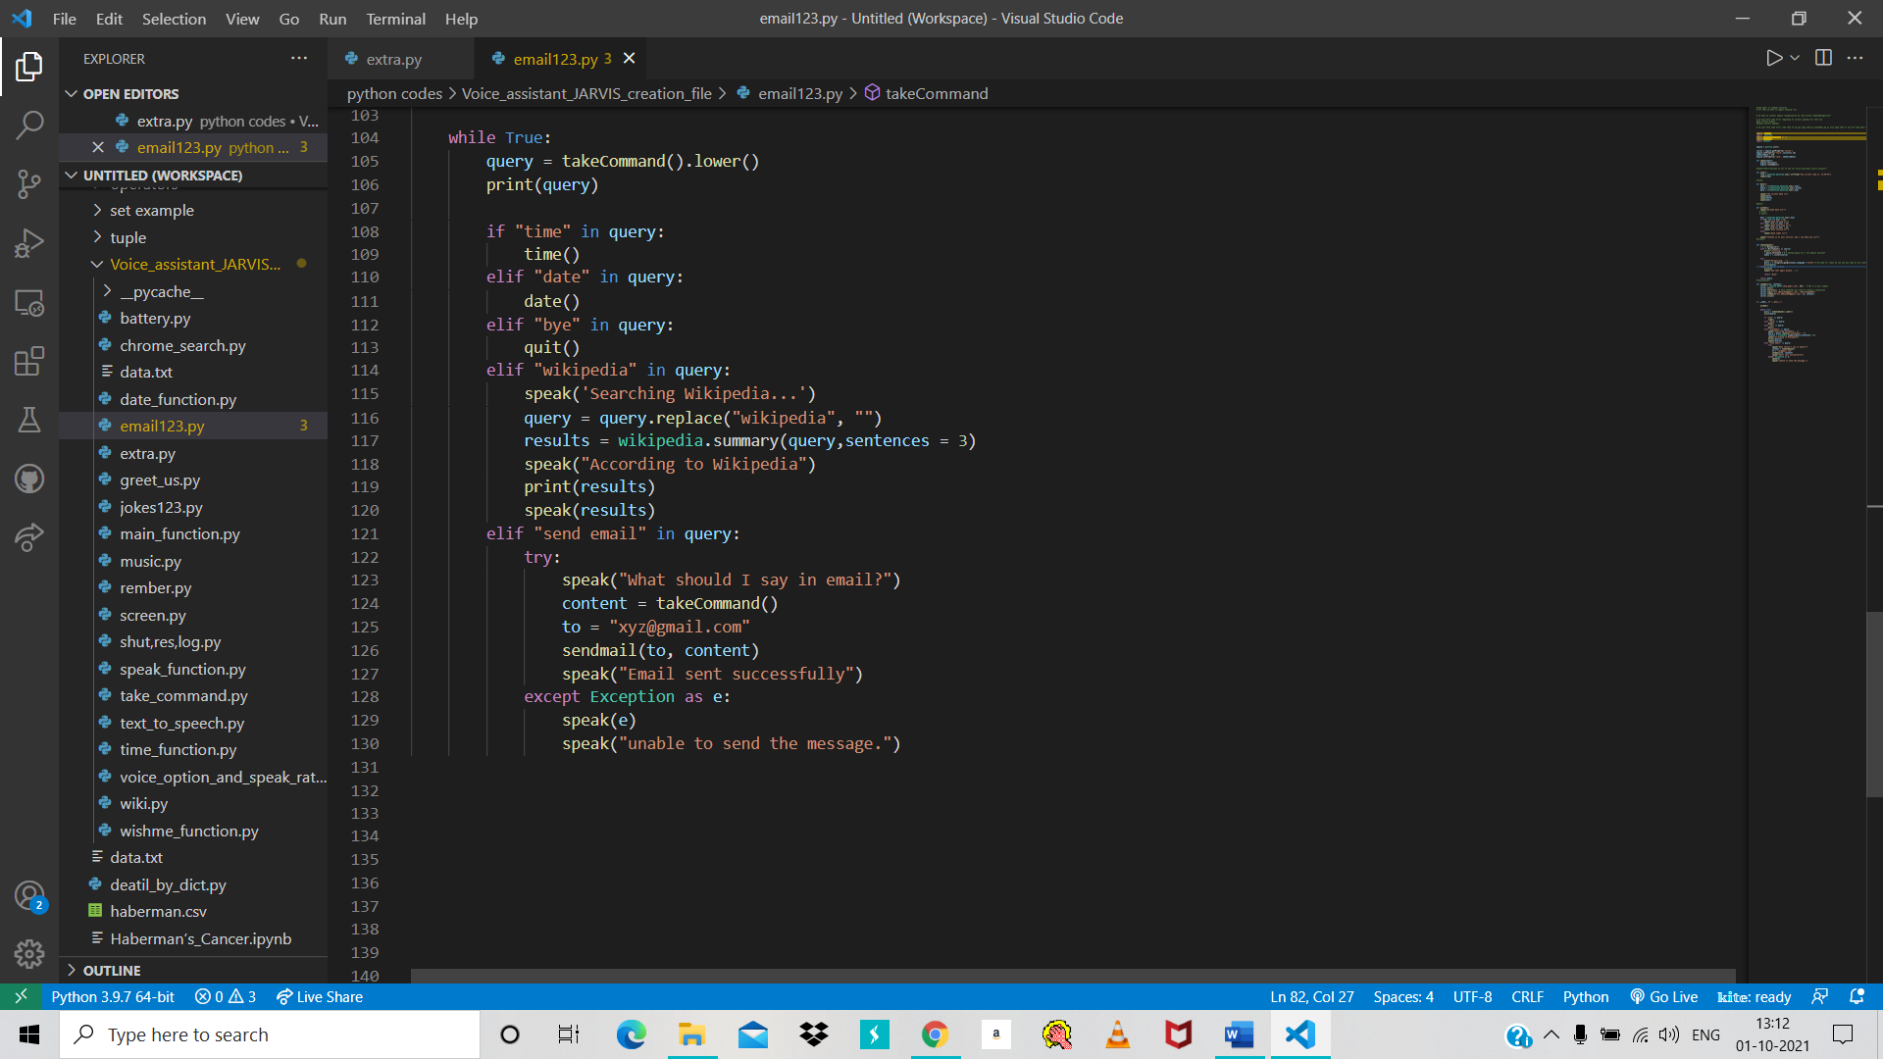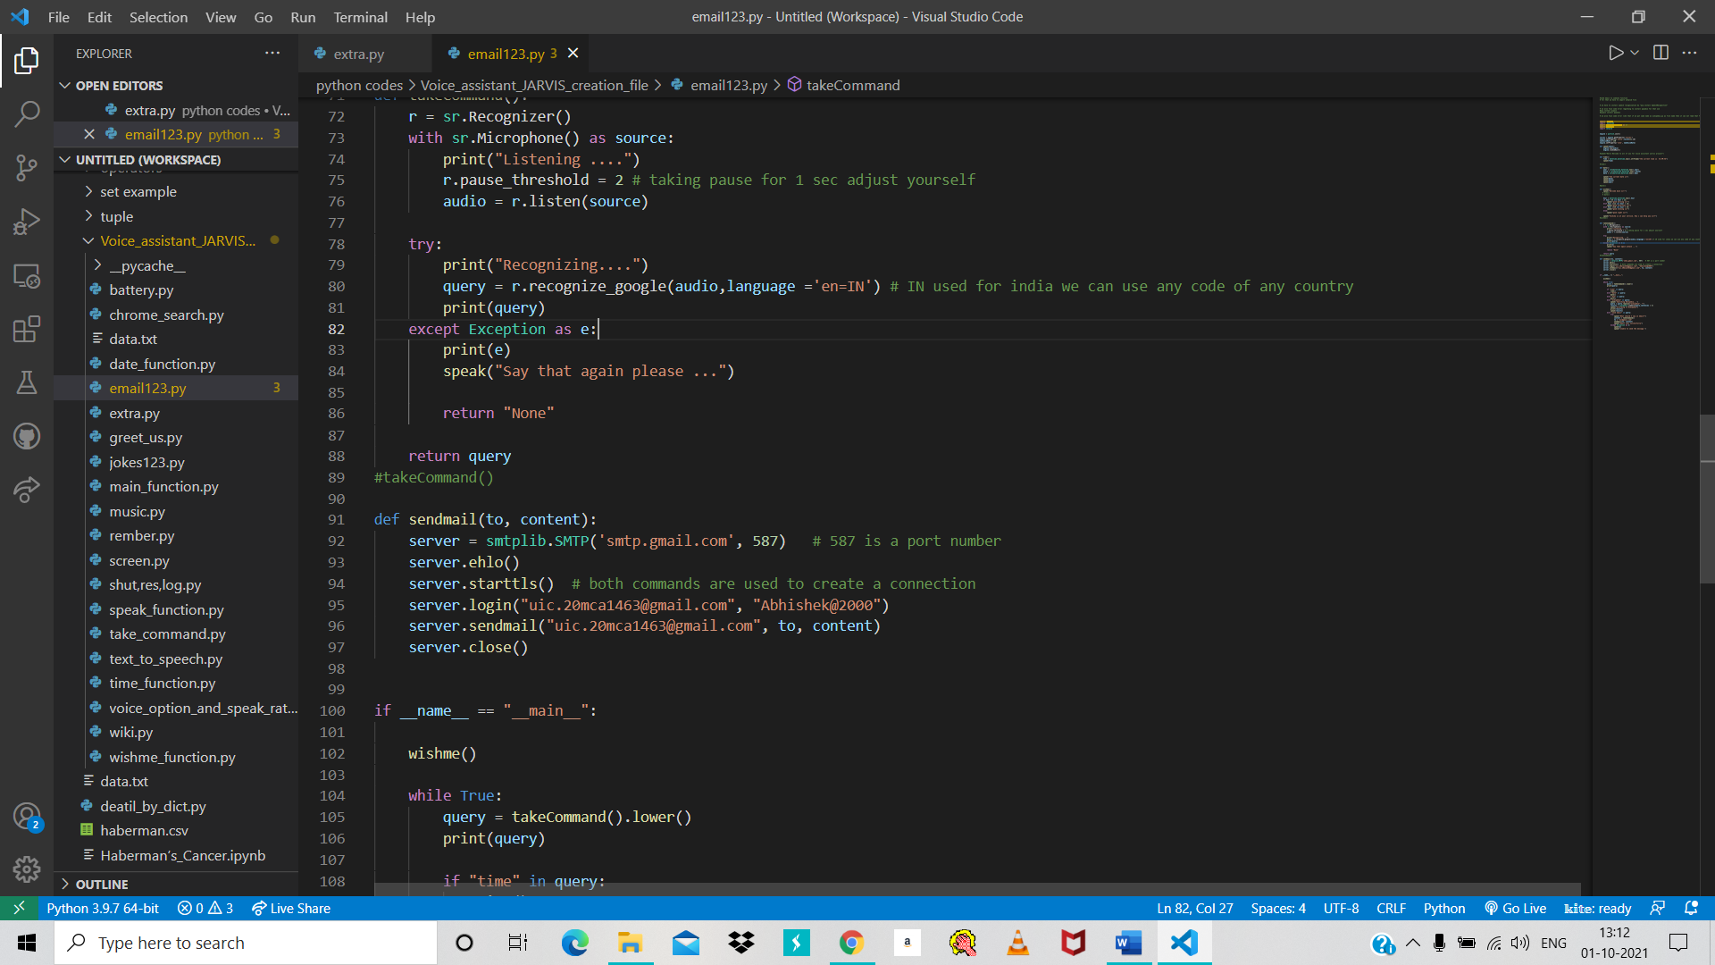

Figure 26 email 3

Write yor email address and password

Figure 27 email 2

## 

Figure 28 email 4

## Chrome search

## Logout, shutdown and restart

## Play song

## Remember function

## Screenshot function

## CPU and battery update

## Joke’s function

# Chapter 4 : Coding

### Complete project Coding

Figure 29 complete coding 1

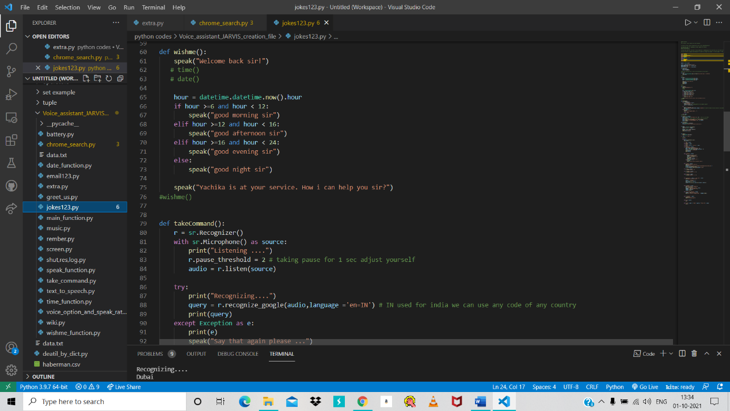

Figure 30 Complete coding 2

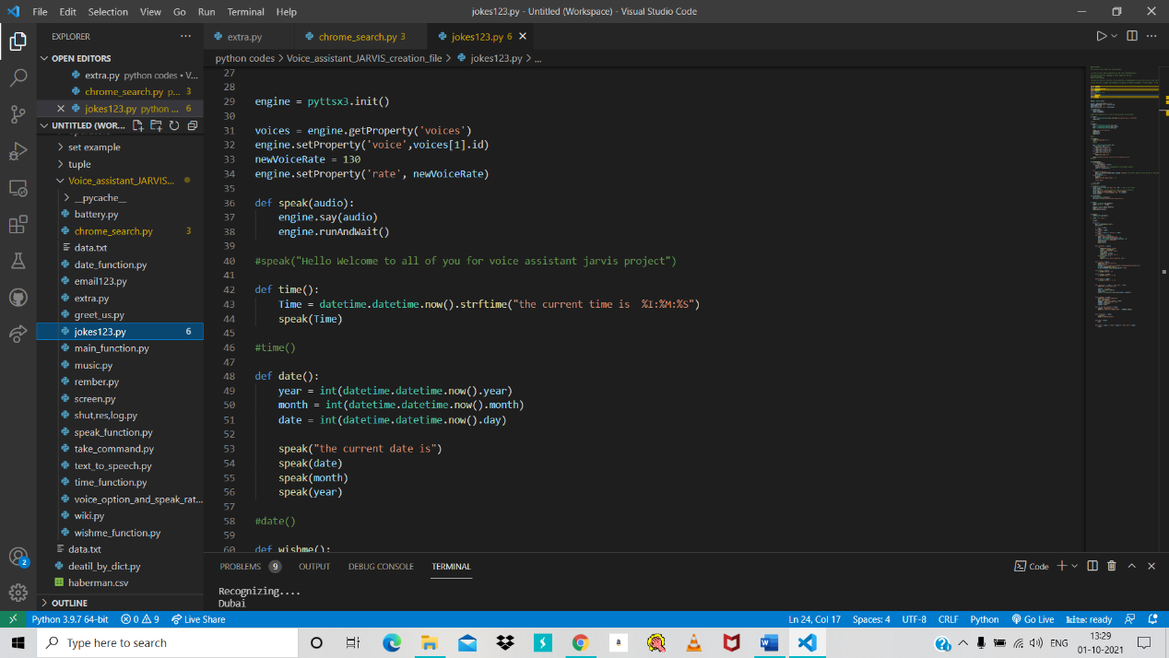

Figure 31 completing coding 3

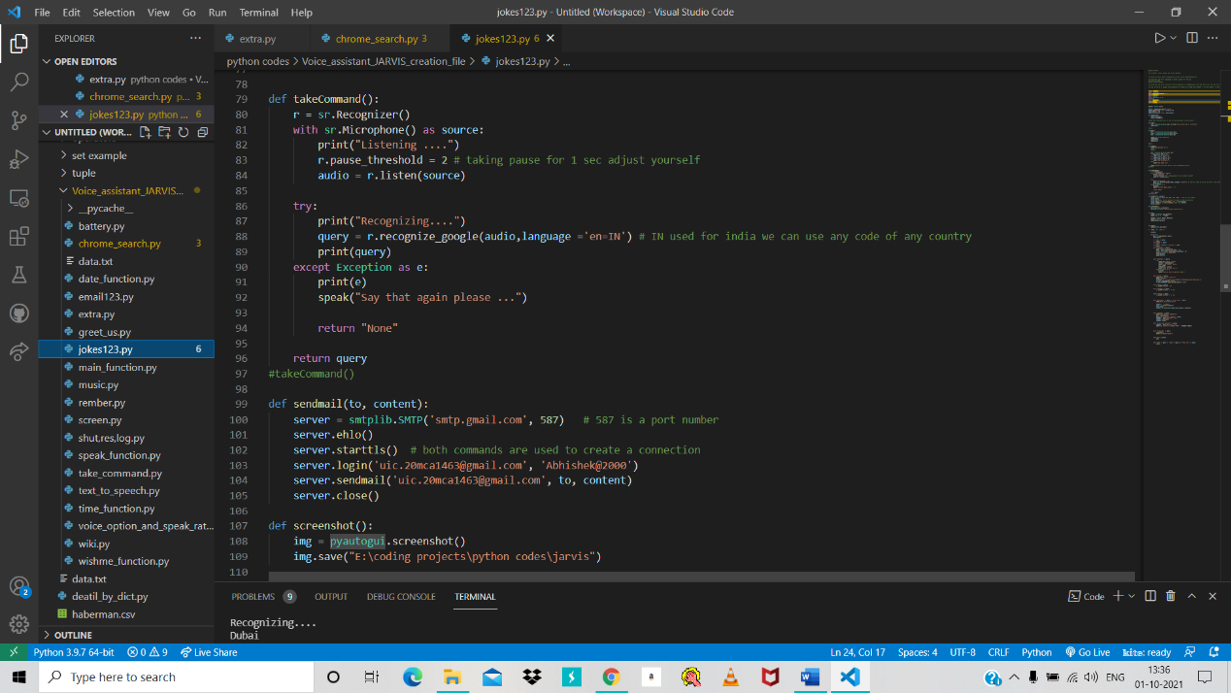

Figure 32 complete code 4

## 

Figure 33 Complete code 5

Figure 34 Complete code 6

# 

Figure 35 complete code 8

Figure 36 Complete code 7

### Errors Handling

# 

Figure 37 Error

# Chapter 5: Testing

### Import Library

We have to import some libraries for execution. these libraries are divided by module.

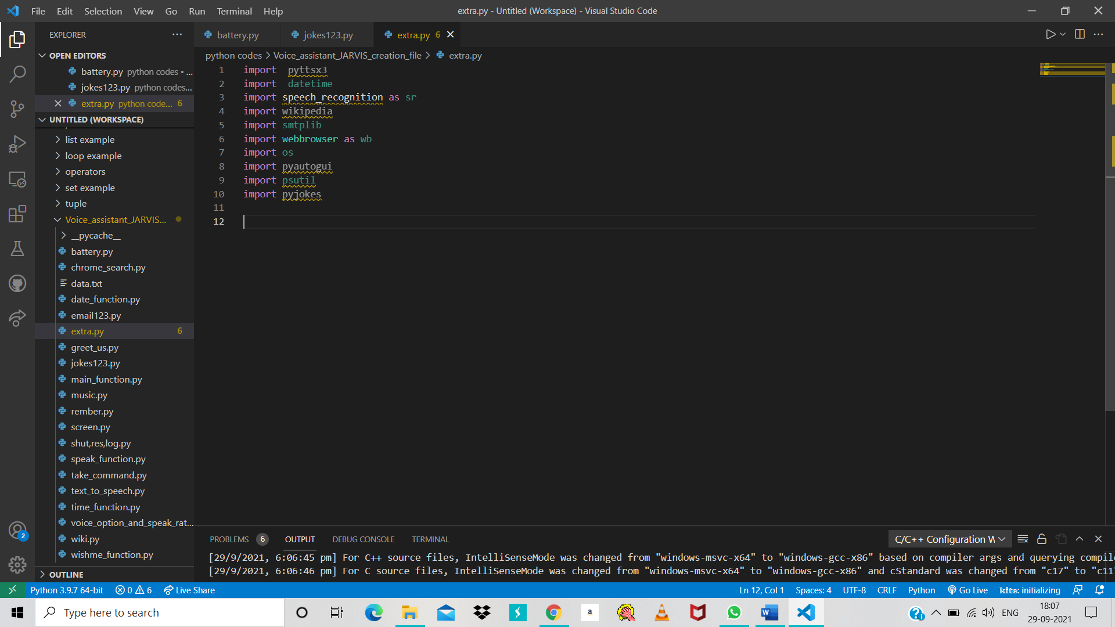

Figure 38 libraries

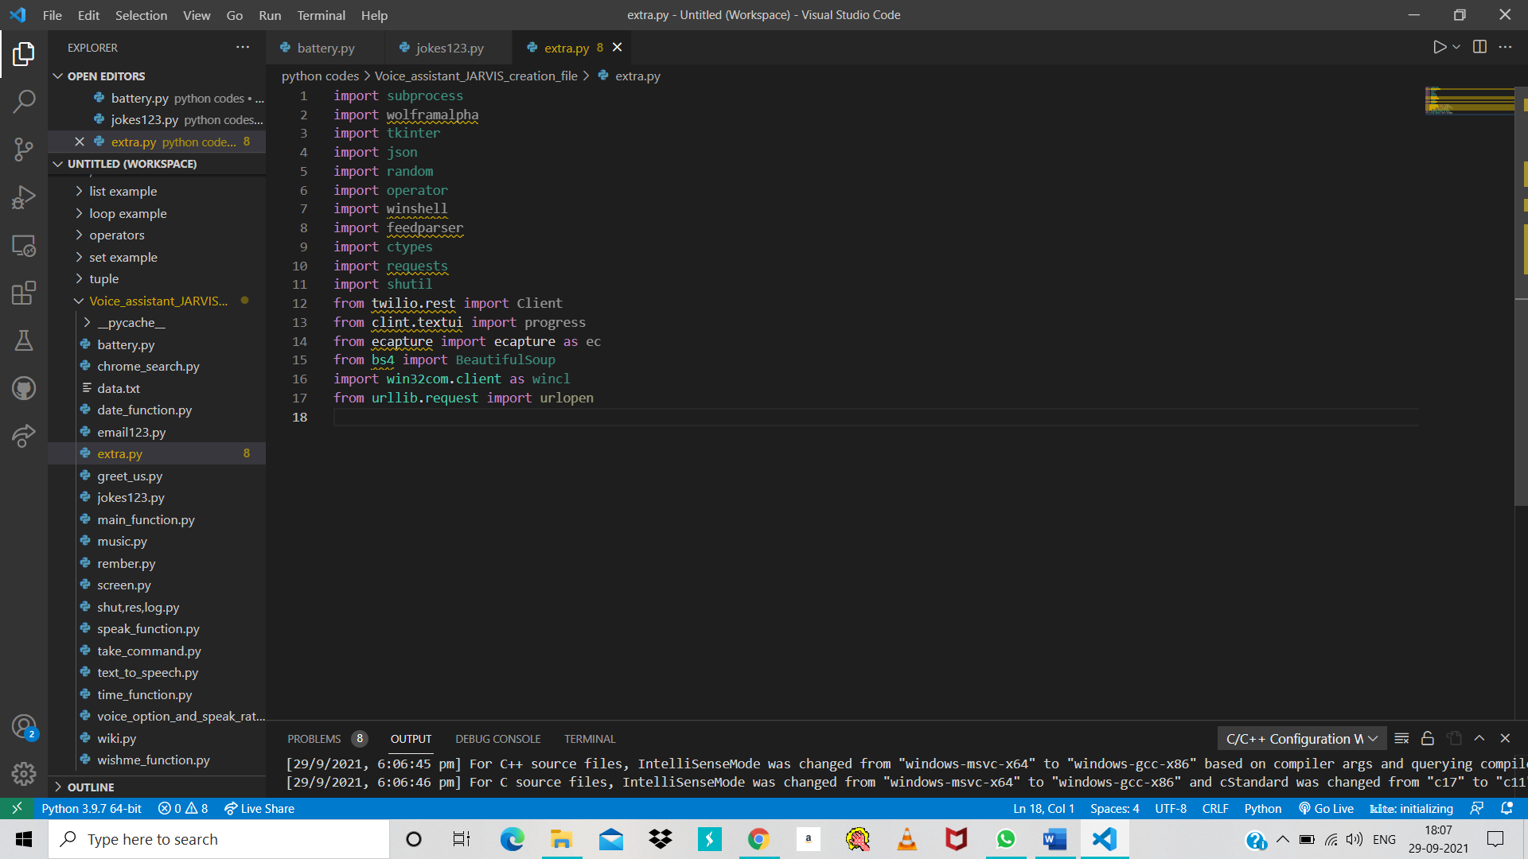

Figure 39 libraries 2

### Modules

For importing libraries, we have to install some modules in the software. But these modules are two types:

1. In built Module = these modules already install in python so we have to import that module directly.
2. Install Module = we have to install these all module firstly then we can import libraries.

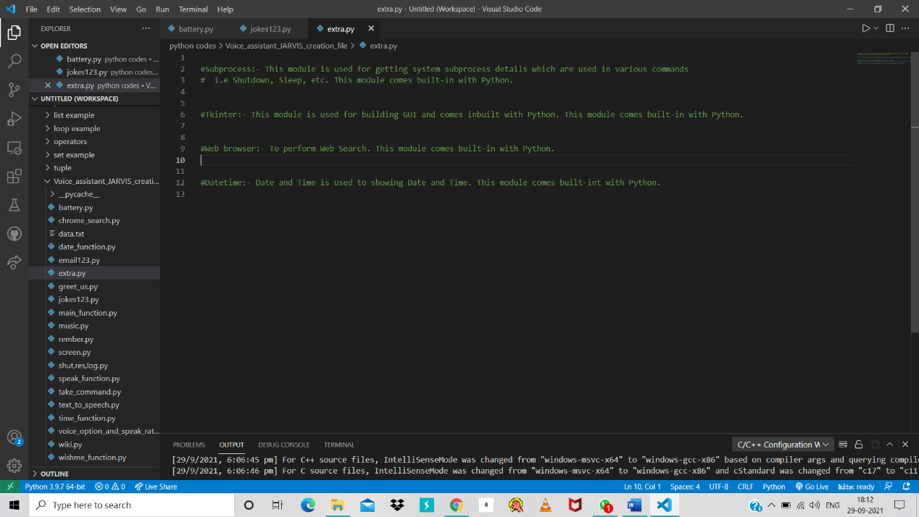For more detail see the below figures.

Figure 40 in built module

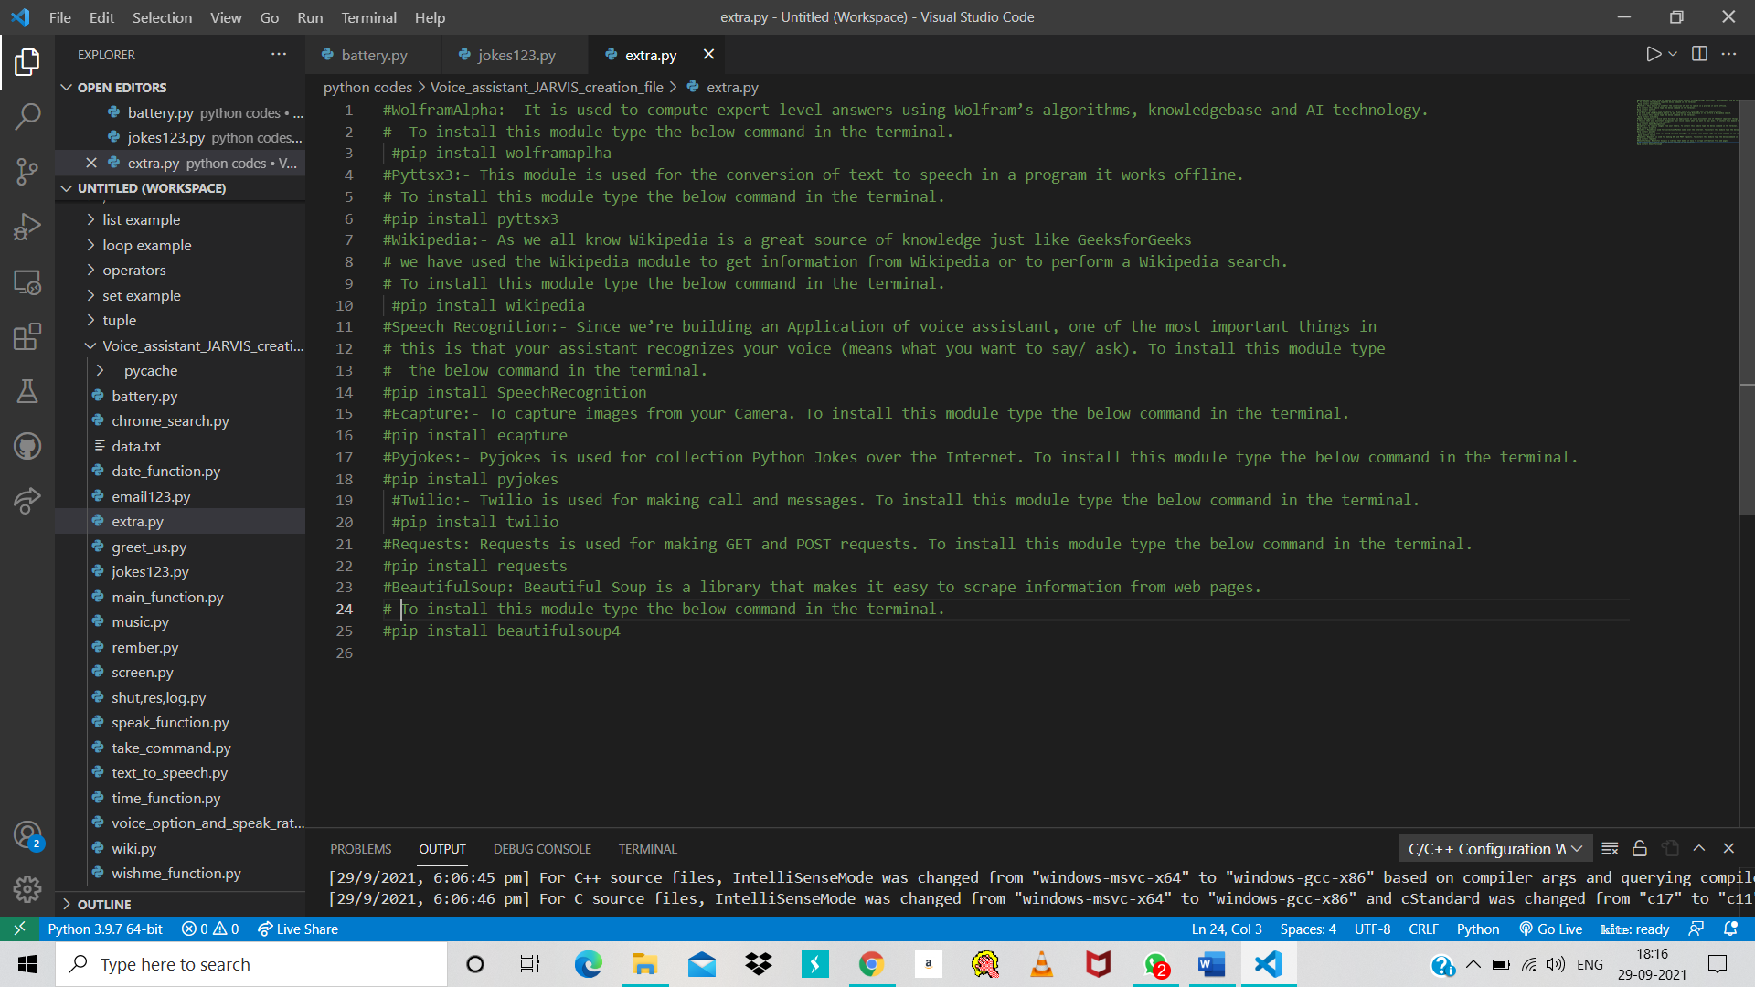

Figure 41 in built module 2

### Checking Headphone

Initial step of this method is to examine whether or not the mike/webcam works properly. we have a tendency to should check whether it records properly Associate in Nursing checking microphone high volumes, etc are high. initial check whether the USB microphone is connected properly victimisation the command “subs”. Check whether our mic/webcam comes beneath the list.(Lenat & Guha, 1989) Then checking the recording in highvolumes.to do this, sort the command “Alsamixer” within the terminal. so, an interface appear, arrow buttons are wont to increase the volumes. choose the actual USB mic/webcam from the list and check at high volumes. to examine recording is completed properly use the command “are cord –l”. use the command “arecord –D plughw:1, 0test.wav” to record sound. The sound is recorded in test.wav. to pay attention to the recorded sound, insert your headphones in your raspberry pi device and enter the command “a play test.wav” within the terminal. The HMM algorithm was used to complete recognition for an intelligent voice assistant application utilising Google Server. The conversion of acoustic speech into a collection of words is accomplished by a software system component in this technique. Speech recognition system accuracy differs in vocabulary quantity and confusability, speaker dependency vs. independence, voice modalities (separated, interrupted, or uninterrupted voice, scanned or unscripted voice), task and language limitations, and task and dialect limitations.(Moravec, 1988)

Feature extraction, HMM phone model training, wordbook preparation, synchronic linguistics estimate, and sentence decoding are the five components that make up the system. Systems for speech recognition that are supported Markoff's Secret Models that are most commonly used in today's fashionable technology. They model using the word or speech sound as a unit. The model's output is probabilistic and concealed.



Figure 42google assistant tools

State functions are not deterministically stated. The state sequence across the model is unknown..(Shapiro, 1992)

.

# Chapter 6: Documentation

### GOOGLE ASSISTANT

Google Assistant is a virtual assistant powered by artificial intelligence that is primarily available on mobile and smart home devices. The Google Assistant, unlike the company's previous virtual assistant, Google Now, can have two-way discussions.(Minsky, n.d.)

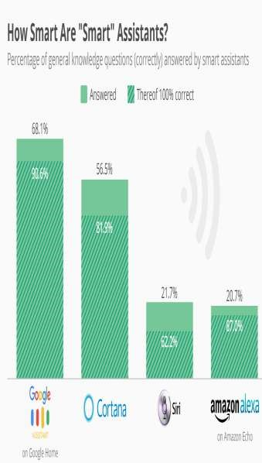

Figure 43 Smart Assistant Graph

### **Security** and Privacy Concerns

This is largely due to security and privacy issues, which have been stated in several studies (Pfeifle, 2018; Lei et al., 2017), as devices should be listening at all times in order to respond to users Luteal. conducted interviews with seventeen smart speaker users and seventeen non-users to learn about their reasons for and against embracing this new technology, as well as their privacy assumptions and concerns. The majority of them bought the devices to be among the first to utilise the technology and to be early adopters. Luteal. investigate users' perceptions of privacy and their usage of privacy (Poli et al., 2008) Text, on the other hand, was just as effective as voice in inducing human-like impressions of the voice assistant whenever the knowledge sensitivity and individual privacy concerns were high.

# Chapter 7: Conclusion And Future Scope

### Conclusion

An examination of the use of voice assistants in the home and for academic purposes was given. Children can move with voice assistants and create simple requests, according to studies (Sciuto et al., 2018; Beirl et al., 2019; Druga et al., 2017; Yuan et al., 2019; Lovato et al., 2019). Kids exhibit a lot of enthusiasm, feel that voice assistants are a good source of information, and they could change their approach to how they ask questions as they get more competent in voice interaction. (Savago et al., 2019; Kowalski et al., 2019) People with disabilities are already using voice assistants and smart speakers. psychological feature impairments or visual problems, according to the findings of four related research, despite the fact that they weren't developed for them at initially. Abdulrahman Tal. argue that vocal contact is convenient for blind individuals and may play a key role in instilling emotions of independence and direction in them. Students are expected to demand personal resources from smart speakers and voice assistants in the future, rather than a passive environment, according to experts. Dou say and Hall conducted a large-scale study with ninety primary children and 90 (Lakoff & Núñez, 2000)

Furthermore, children tend to be satisfied with the use of technology, which shows a high level of involvement. The simultaneous use of voice assistants in households and in the classroom is a crucial topic that has yet to be researched. Because voice assistants and smart speakers are becoming more popular, it would be interesting to investigate how they might be used as study companions both in and out of the classroom. Security and privacy concerns, according to (Searle, 1998), are key downsides for users of voice assistants and smart speakers. Furthermore, Lei et al. investigated the security flaws in Amazon Echo Dot devices and concluded that acoustic assaults may be carried out even when the victims are not at home. (Minsky, 2006)

### Limitations and future research

This study has some limitations. First, 3 VA assistant mobile applications were accustomed discover temperament traits. Future analysis ought to measure the impact of voice recognition, social presence and social image on consumers’ psychological feature load. Second, our sample size was limited. Future research should additionally explore personality traits associated the sensible speakers, together with Amazon’s Show or Apple’s Home. Further, we propose examining time distortion to search out if and the way it transforms client experience. (Terzopoulos and Satratzemi 2020)

# References

*Artificial intelligence - Wikipedia*. (n.d.). Retrieved 16 September 2021, from https://en.wikipedia.org/wiki/Artificial_intelligence#References

*Hey, Alexa: Stop recording me - The Washington Post*. (n.d.). Retrieved 16 September 2021, from https://www.washingtonpost.com/technology/2019/05/06/alexa-has-been-eavesdropping-you-this-whole-time/

Human, G. (2018). Tribute to a “good fella”. *Industrial Marketing Management*, *69*, 129–130.

Kumar, V., Lahiri, A., & Dogan, O. B. (2018). A strategic framework for a profitable business model in the sharing economy. *Industrial Marketing Management*, *69*, 147–160.

Kurzweil, R. (2005). *The singularity is near : when humans transcend biology*. 652.

Kurzweil, R., & Jaroch, D. (n.d.). *The age of intelligent machines*. 565.

Lakoff, G., & Núñez, R. E. (2000). *Where mathematics comes from : how the embodied mind brings mathematics into being*. 492.

Lenat, D. B., & Guha, R. V. (1989). *Building large knowledge-based systems : representation and inference in the Cyc project*. 372.

Liu, W., Xu, Y., Fan, D., Li, Y., Shao, X. F., & Zheng, J. (2021). Alleviating corporate environmental pollution threats toward public health and safety: The role of smart city and artificial intelligence. *Safety Science*, *143*.

Minsky, M. (n.d.). *Computation : finite and infinite machines*. 317.

Minsky, M. (2006). *The emotion machine : commonsense thinking, artificial intelligence, and the future of the human mind*. 387.

Moravec, H. P. (1988). *Mind children : the future of robot and human intelligence*. 214.

Munoz, J., Rezaei, A. A., Jalili, M., & Tafakori, L. (2021). Deep learning based bi-level approach for proactive loan prospecting. *Expert Systems with Applications*, *185*.

O’Brien, J. A., & Marakas, G. M. (2011). *Management information systems*. 673.

Penrose, R. (1989). *The emperor’s new mind : concerning computers, minds, and the laws of physics*. 466.

Poli, R., Langdon, W. B., & McPhee, N. F. (2008). A Field Guide to Genetic Programing. *Wyvern*, *March*, 8. http://www.essex.ac.uk/wyvern/2008-04/Wyvern April 08 7126.pdf

Searle, J. R. (1998). *Mind, language, and society : philosophy in the real world*. 175.

Shapiro, S. C. (1992). *Encyclopedia of artificial intelligence*. 35.

Sharma, A., & Syam, N. (2018). Sales and customer development: An agenda for inquiry. *Industrial Marketing Management*, *69*, 133–134.

Shende, D., Umahiya, R., Raghorte, M., Bhisikar, A., Bhange, A., & Professor, A. (2019). *AI Based Voice Assistant Using Python*. *6*(2), 506–509. www.jetir.org

Syam, N., & Sharma, A. (2018). Waiting for a sales renaissance in the fourth industrial revolution: Machine learning and artificial intelligence in sales research and practice. *Industrial Marketing Management*, *69*, 135–146. https://doi.org/10.1016/J.INDMARMAN.2017.12.019

Thro, E. (1993). *Robotics : the marriage of computers and machines*. 119.

Ulaga, W., & Kohli, A. K. (2018). The role of a solutions salesperson: Reducing uncertainty and fostering adaptiveness. *Industrial Marketing Management*, *69*, 161–168.

van der Borgh, M., Xu, J., & Sikkenk, M. (2020). Identifying, analyzing, and finding solutions to the sales lead black hole: A design science approach. *Industrial Marketing Management*, *88*, 136–151.

*Waiting for a sales renaissance in the fourth industrial revolution: Machine learning and artificial intelligence in sales research and practice - ScienceDirect*. (n.d.). Retrieved 16 September 2021, from https://www.sciencedirect.com/science/article/abs/pii/S0019850117302730

Weizenbaum, J. (n.d.). *Computer power and human reason : from judgment to calculation*. 300.